Contents

**1. WEBSITE USER GUIDE**

**1.1 User Information**

1.1.1 Login 2

1.1.2 Forgot password 3

1.1.3 View user information after successful login 5

1.1.4 Change password 6

1.1.5 Logout 7

**1.2 Registration**

**1.3 Website**

1.3.1 Animals guide 9

1.3.2 News 10

1.3.3 Events 11

1.3.4 Visit 13

1.3.5 Support 15

1.3.5.1 About us 15

1.3.5.2 Contact Us 16

1.3.5.3 Feedback 16

1.3.5.4 FAQS 17

**2. WEBSITE ADMINISTRATION GUIDE**

2.1 Login Admin Main Page 18

2.2 Add New Admin: 19

2.3 User Accounts: 20

2.3.1 View the account list 20

2.3.2 Add new accounts 21

2.3.4 Edit user accounts: 22

2.3.5 Delete user accounts: 22

2.4 Animal Categories Management: 23

2.4.2 Add new Animal Categories: 24

2.4.3 Edit Animal Categories 24

2.4.4 Delete Animal Categories 25

2.4.5 Search Animal Categories 25

2.5 Animal Management 26

2.5.1 Search Animals 26

2.5.2 List Animals: 26

2.5.3 Add Animals: 27

2.5.4 Delete Animals: 27

2.5.5 Edit Animals: 28

2.6 Post Categories Management 28

2.6.2 Add new Post Categories: 29

2.6.3 Edit Post Categories 29

2.6.4 Delete Post Categories 30

2.6.5 Search Post Categories 30

2.7 Post Management 30

2.7.1 List Post: 30

2.7.2 Add Posts: 31

2.7.3 Delete Posts: 31

2.7.4 Edit Post: 32

2.8 Ranges Management 33

2.8.1 List Ranges: 33

2.8.2 Add Ranges: 34

2.8.3 Delete Ranges: 34

2.8.4 Edit Ranges: 35

2.9 Random Background Management 37

2.9.1 List random Backgrounds: 37

2.9.2 Add Random Backgrounds: 37

2.9.3 Delete Random Backgrounds: 38

2.9.4 Edit Random Backgrounds: 38

2.10 Author Management 39

2.10.1 List Authors: 39

2.10.2 Add Authors: 40

2.10.3 Delete Authors: 40

2.10.4 Edit Authors: 41

2.11 Event Categories Management 42

2.11.1 List Event Categories: 42

2.11.2 Add Event Categories: 42

2.11.3 Delete Event Categories: 43

2.11.4 Edit Event Categories: 43

2.12 Events Management 44

2.12.1 List Events: 44

2.12.2 Add Events: 45

2.12.3 Delete Events: 45

2.12.4 Edit Events: 46

2.13 Feedback Categories Management 47

2.13.1 List Feedback Categories: 47

2.13.2 Add Feedback Categories: 48

2.13.3 Delete Feedback Categories: 48

2.13.4 Edit Feedback Categories: 49

2.14 Feedbacks Management 50

2.14.1 List Feedbacks: 50

2.14.2 Delete Feedbacks: 50

2.14.3 Edit Feedbacks: 51

2.15 Bookings Management 52

2.15.1 List Bookings: 52

2.15.2 Add Bookings: 52

2.15.3 Delete Bookings: 53

2.15.4 Edit Bookings: 54

**1. WEBSITE USER GUIDE**

This section provides guidance for users and visitors of Nexus Aquarium.

**1.1 User Information**

## Login

This function is used to login to the system. Target users: All users in the system.

Step 1: Go to the login page by clicking the ‘Login’ button

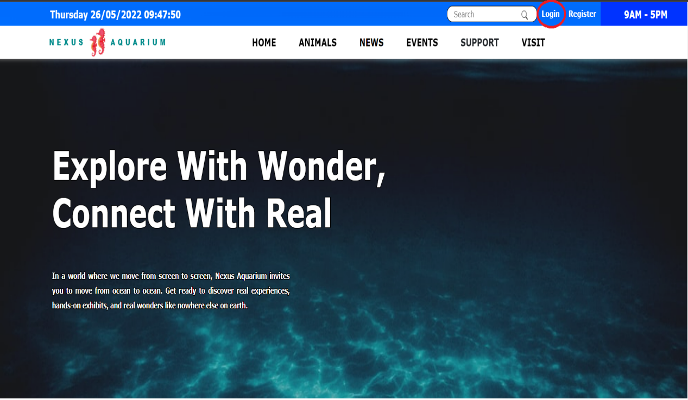

* Step 2: Enter your Email and Password information

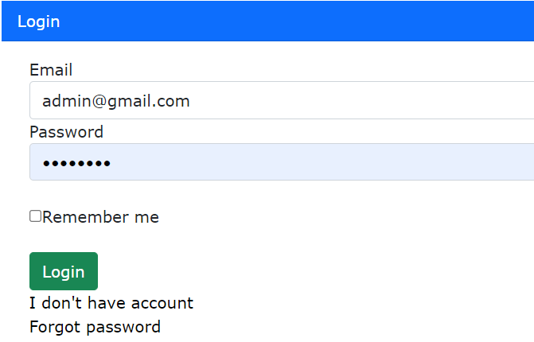

* Step 3: Press Enter or click the Login button to login to the system

### 1.1.2 Forgot password

If you forgot your password, you can reset password by clicking the ‘Forgot password’ in login page.

* Step 1: Go to the login page
* Step 2: Click to the ‘Forgot password’

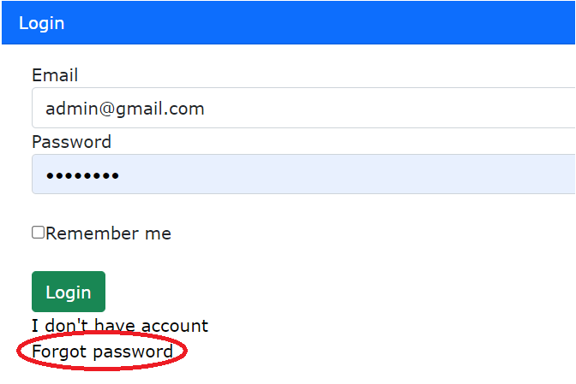

* Step 3: Enter your Email then click ‘Next’

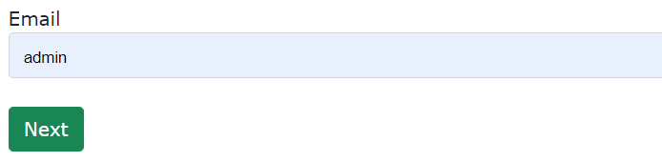

* Step 4: The system will send the verification link to your email. Following the link to reset password

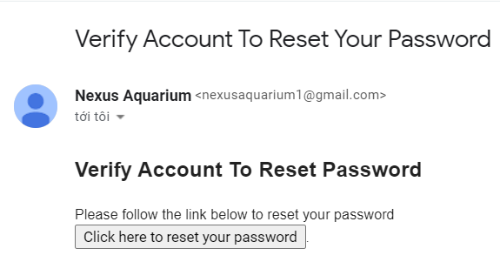

- Step 5: Now you can set your new password and save.

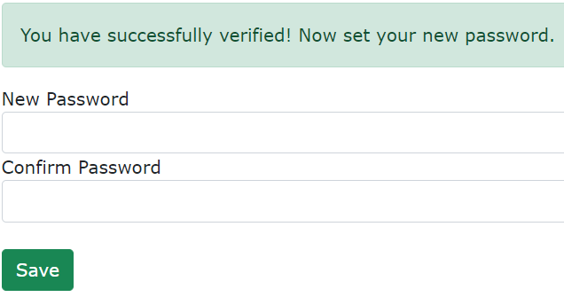

### 1.1.3 View user information after successful login

* Step 1: After successfully logging in, hovering over the username or avatar, the sections about personal information will be displayed
* Step 2: Click to View Profile

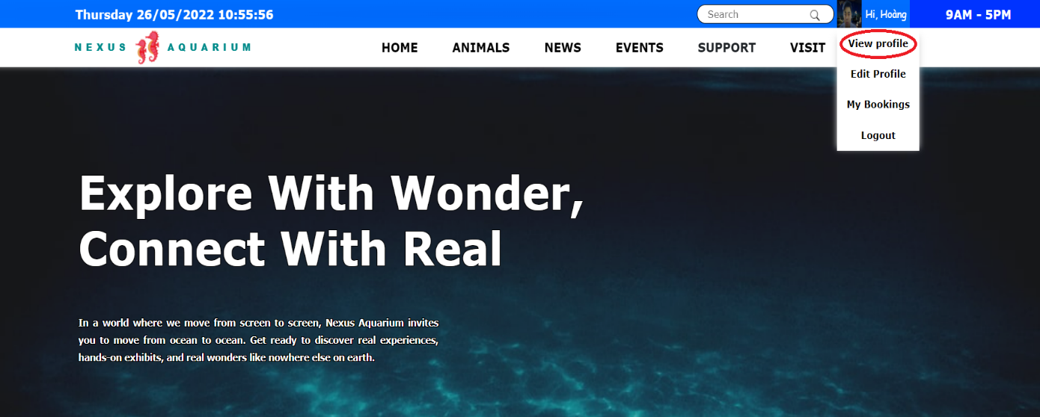

* Step 3: In the view profile display, you can change your password and edit your personal information by clicking the ‘Change password’ button and ‘Edit’ button.

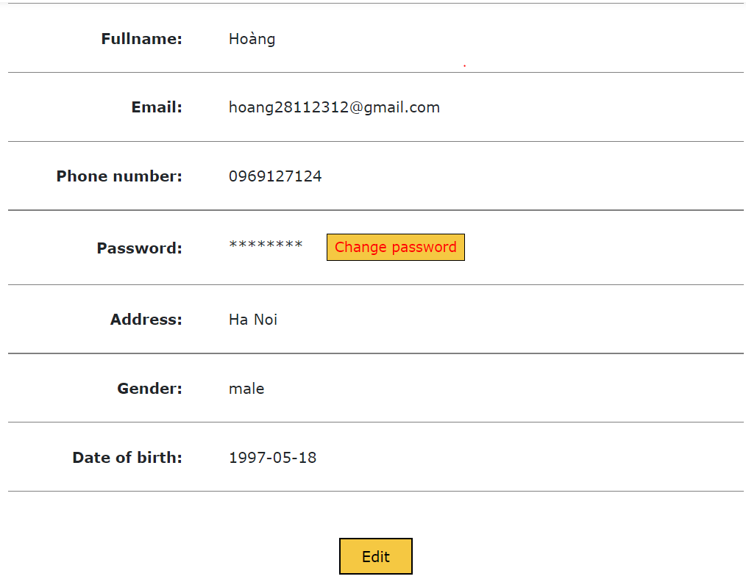

### 1.1.4 Change password

* Step 1: Go to the View profile page
* Step 2: Click to ‘Change password’ button 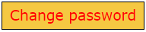
* Step 3: Enter your current password, new password and confirm it
* Step 4: Press Enter or click to ‘Save’ button to save your change

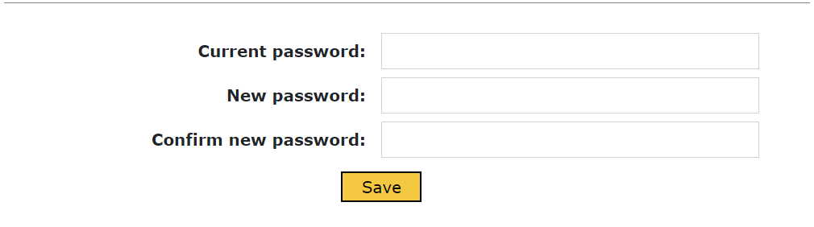

\****Note:*** *Password must be at least 8 characters long, include at least 1 uppercase letter, 1 lowercase letter, 1 number and no special characters.*

### 1.1.5 Logout

This function is used to log out of the system

* Step 1: Hovering over the username or avatar, the sections about personal information will be displayed
* Step 2: Click to ‘Logout’

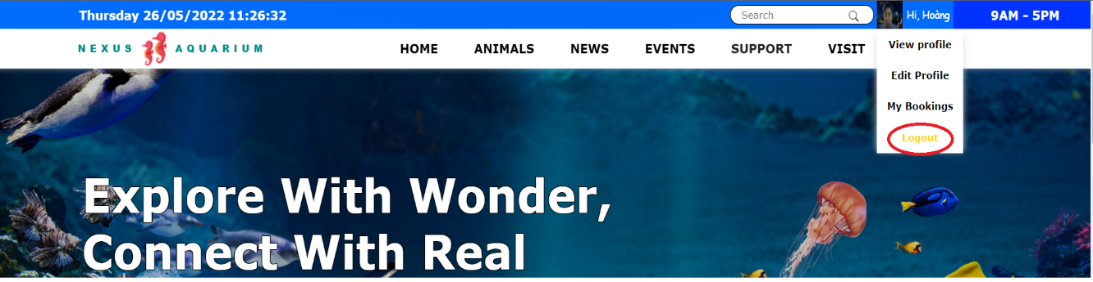

**1.2 Registration**

This function is used to register a new account. Target users: All users of the system.

- Step 1: Go to the register page by clicking the ‘Register’ button or go to the Login page then click to ‘I don’t have account’.

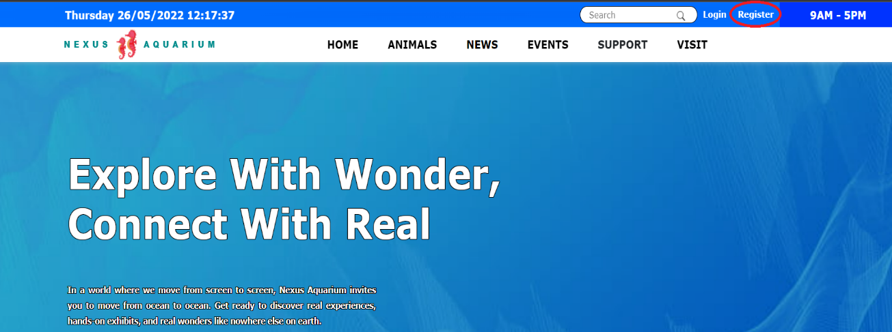

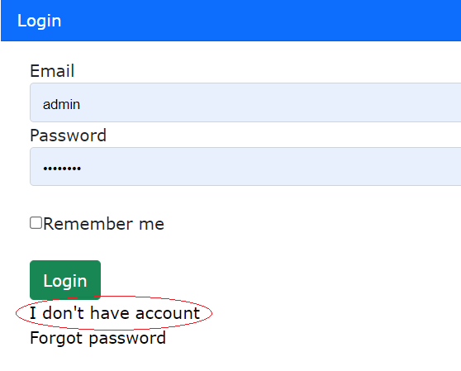

- Step 2: Enter your Fullname, Email, Password and Password Confirmation then press Enter or click to Register button

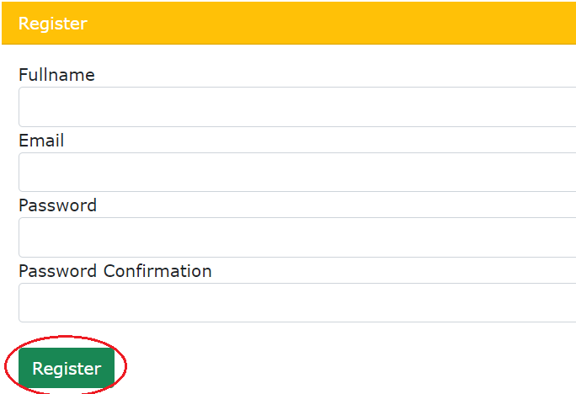

- Step 3: The system will send the verification link to your email. Following the link to verify your email address.

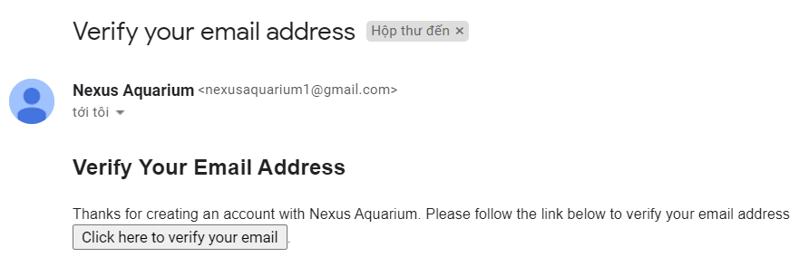

- Step 4: After verified successful, you can login to the system.

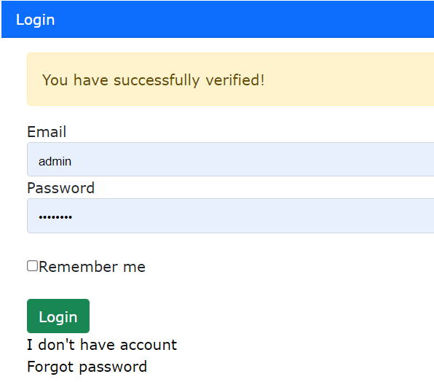

**1.3 Website**

### Animals guide

### This function is used to view information about the animals available at the aquarium

* Step 1: Click to ‘Animals’ on the menu bar



* Step 2: At the animals guide page you can filter by categories and range

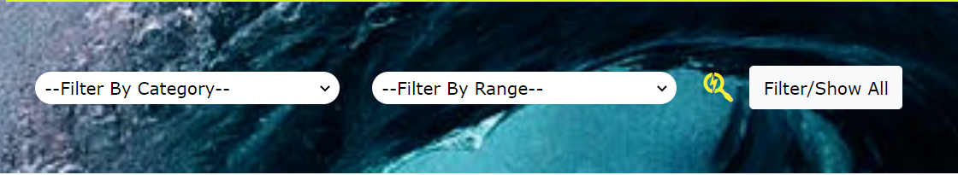

* Step 3: To see more details about animals information, click to animal picture, animal name or ‘View More’.

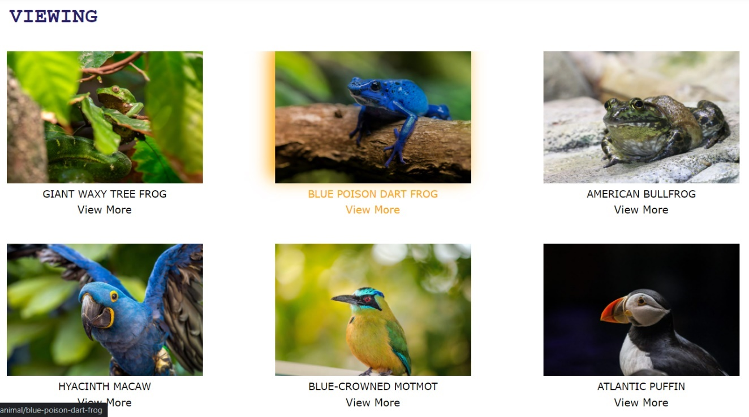

### 1.3.2 News

This function is used to view Nexus Aquarium news, animal stories, information about aquarium partners and more.

* Step 1: Click to ‘News’ on the menu bar



* Step 2: To see more article details, click to article picture, title, or description.

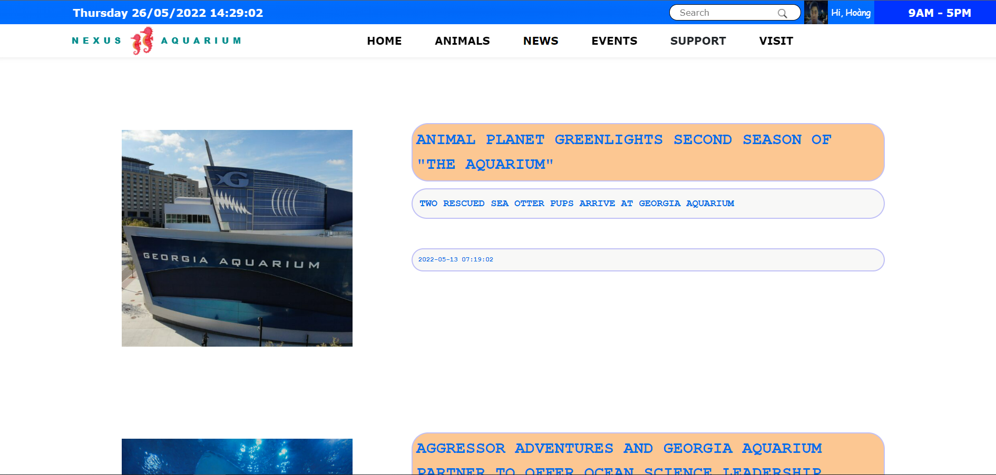

### 1.3.3 Events

This function is used to view information about events held at the aquarium and most importantly, users can book event tickets online here.

* Step 1: Click to ‘Events’ on the menu bar



* Step 2: At the Events page you can filter by categories.



- Step 3: To see more Events details, click to events picture, title, or ‘View More’.

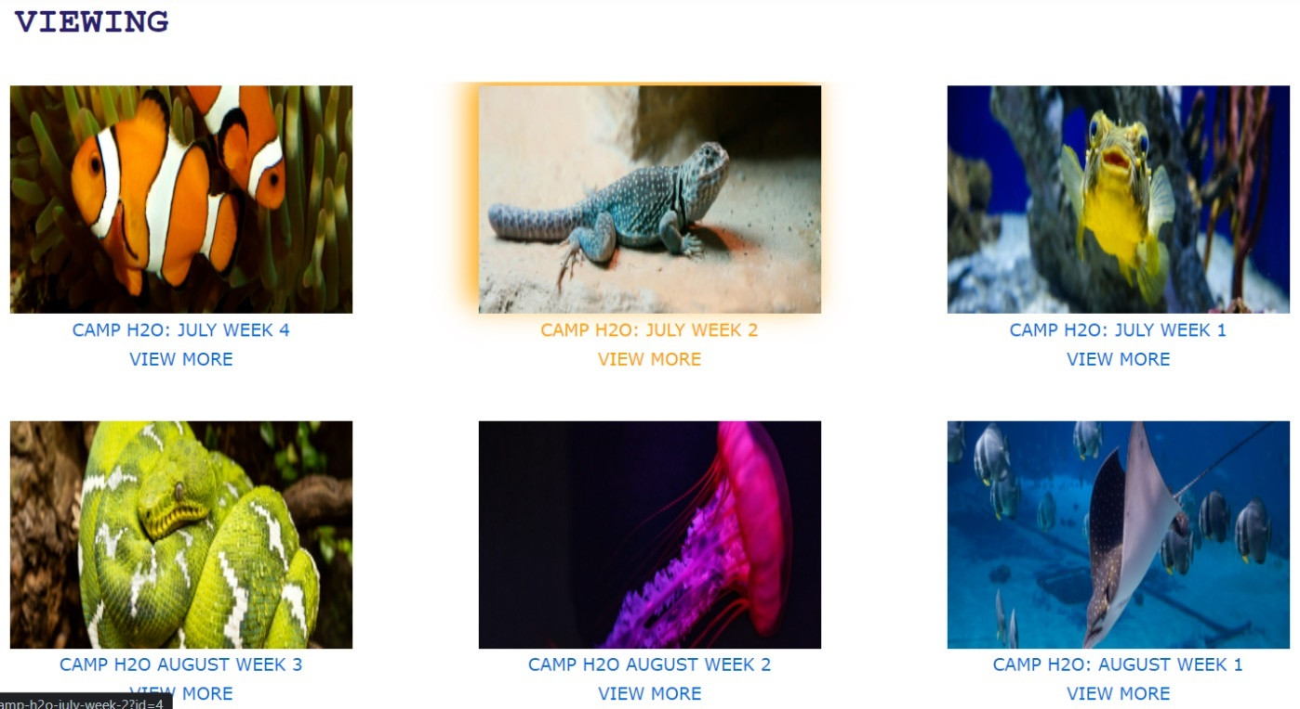

- Step 4: At the event details page, you can see overview of event and the event's information such as event time, venue, event ticket price. You can book tickets to the event by clicking the 'Book now' button (requires to be logged in to the system).

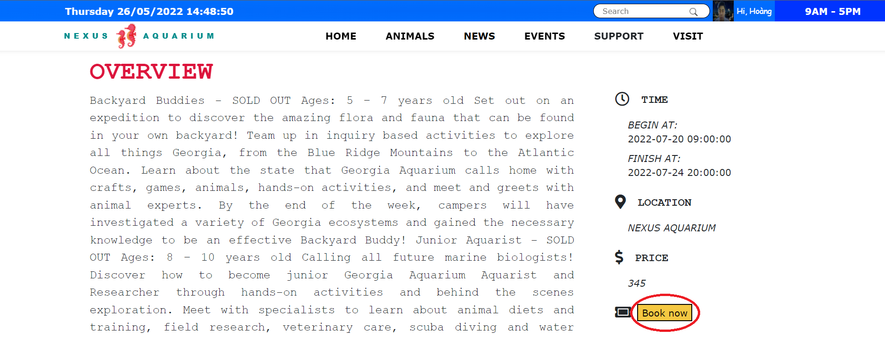

- Step 5: You can confirm your contact information and event’s details again. Then enter the number of tickets you want to book and check the total price. Click to ‘Continue’ button to go to the booking confirmation.

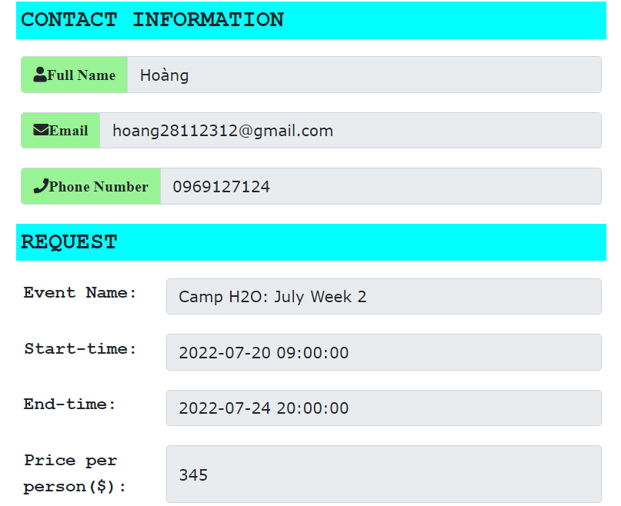 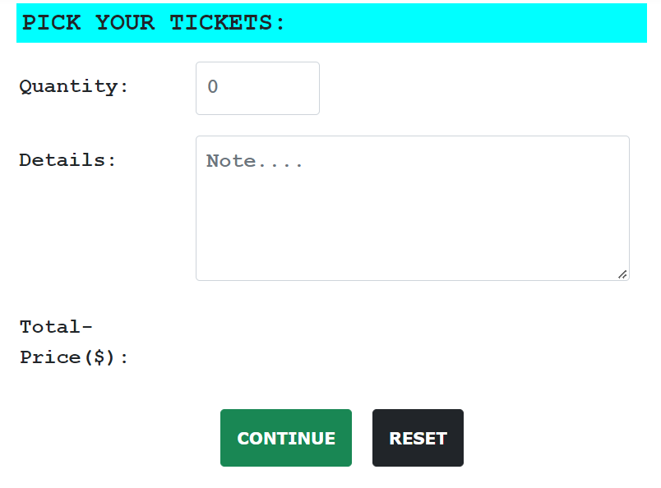

- Step 6: After confirming all the information, click to ‘Book’ button to complete the booking.

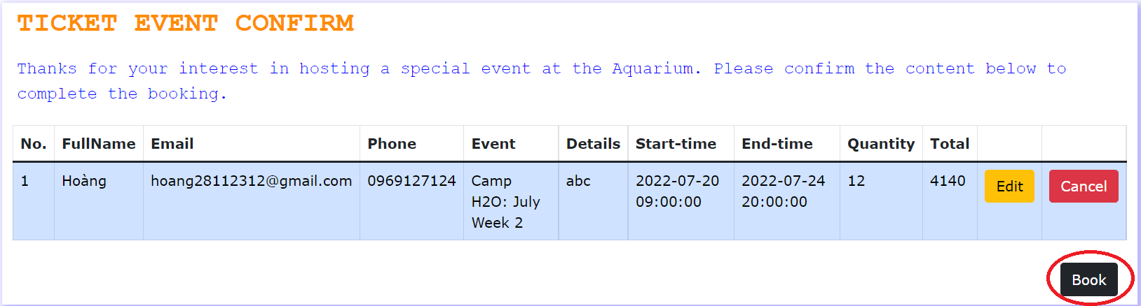

### 1.3.4 Visit

This function is used to view the aquarium's operating hours information and you can book admission tickets online.

* Step 1: Click to ‘Visit’ on the menu bar



* Step 2: At the visit-details page you can see hours of operation of Nexus Aquarium.

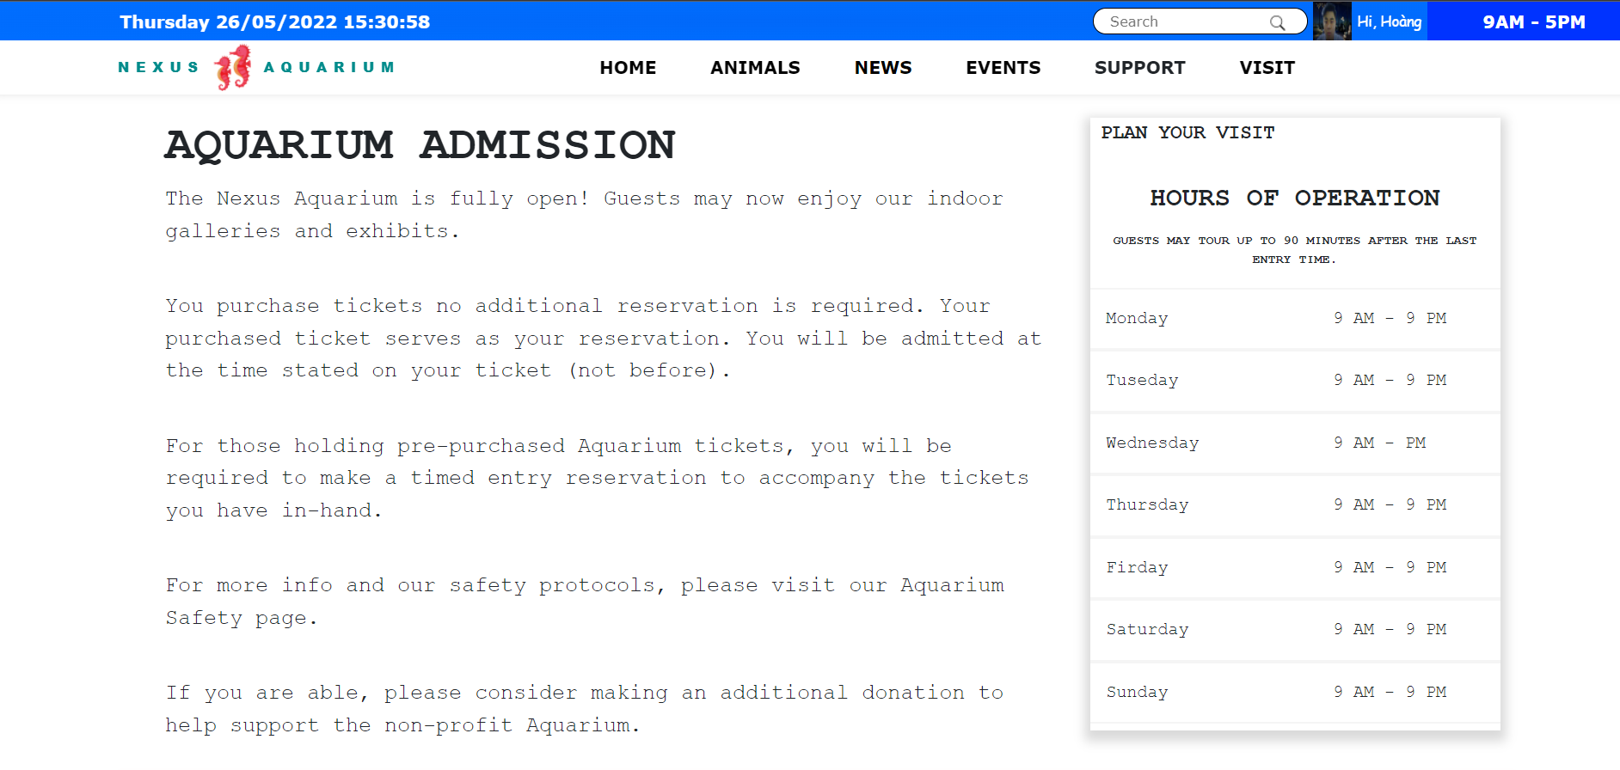

* Step 3: Scroll down and you can see admission ticket informations. Click to ‘BUY TICKET’ button to book tickets (requires to be logged in to the system).

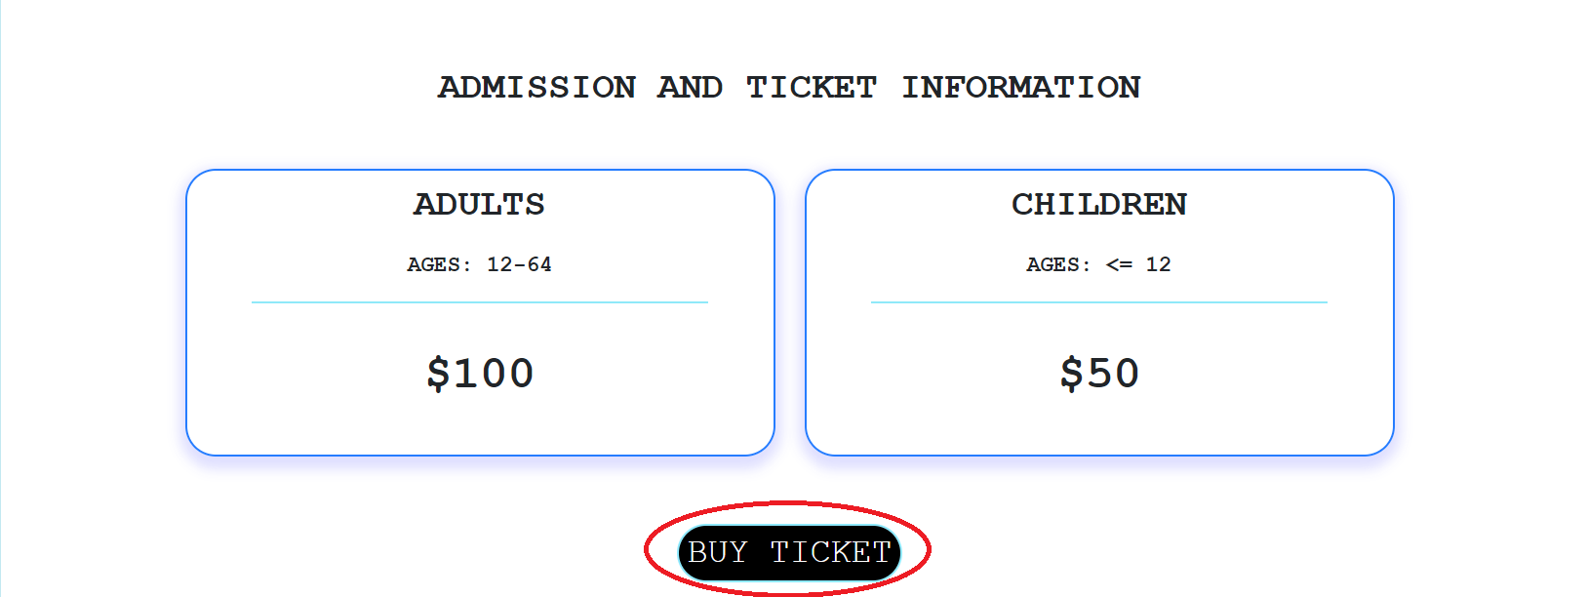

- Step 4: Choose a date to visit Nexus Aquarium

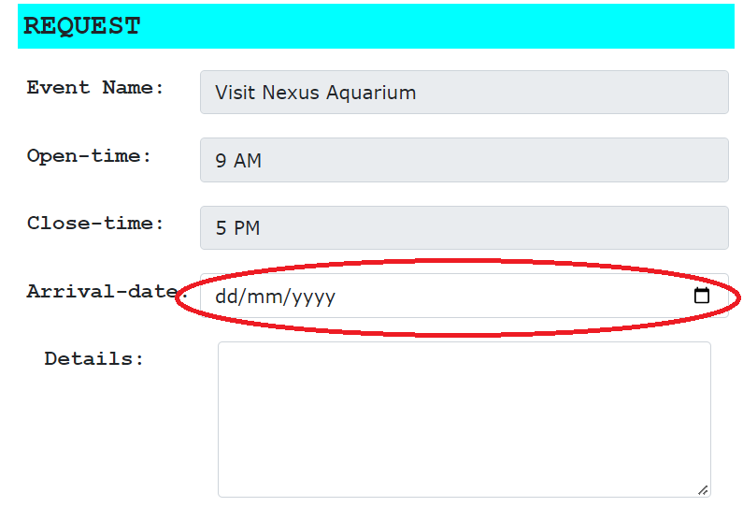

- Step 5: Enter the number of tickets you want to book and check the total price. Click to ‘CONTINUE’ button to go to confirmation booking step.

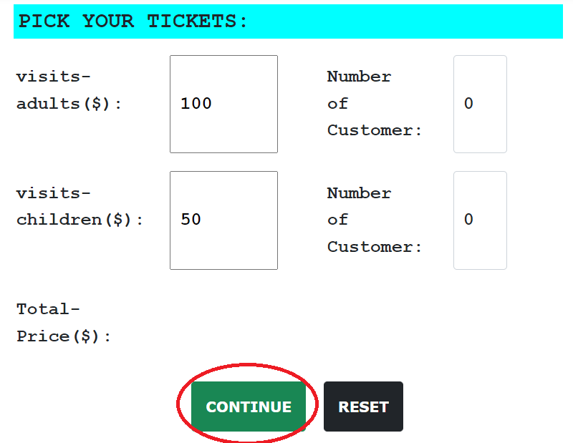

- Step 6: After confirming all the information, click to ‘Book’ button to complete the booking.

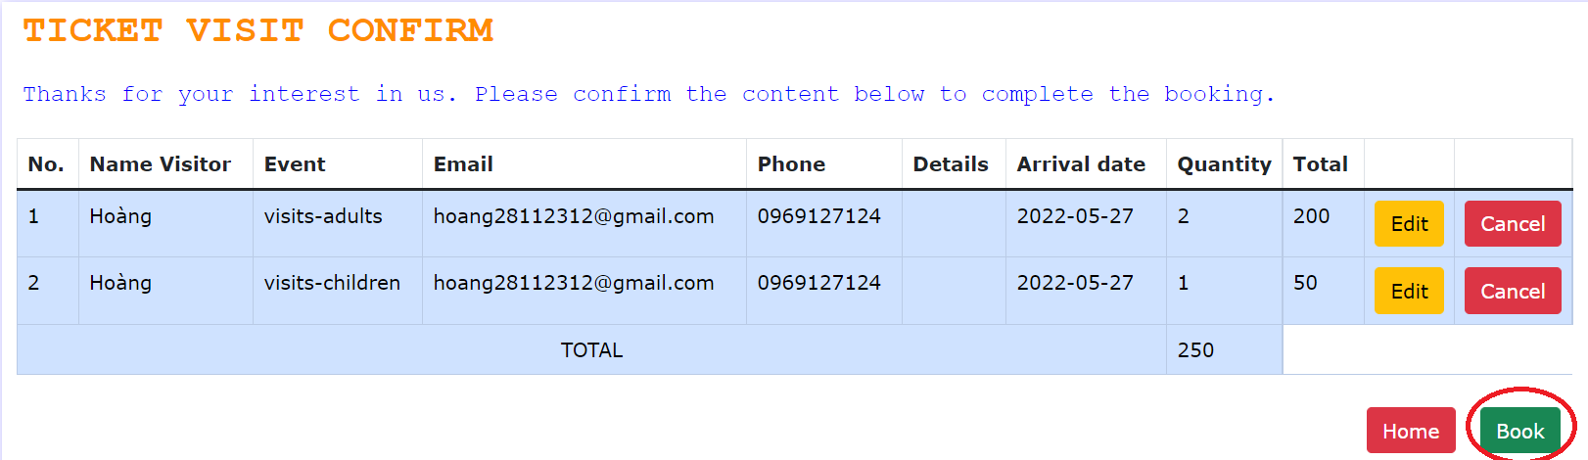

## 1.3.5 Support

## Hold your mouse pointer over the ‘SUPPORT’ and you'll see something like this:

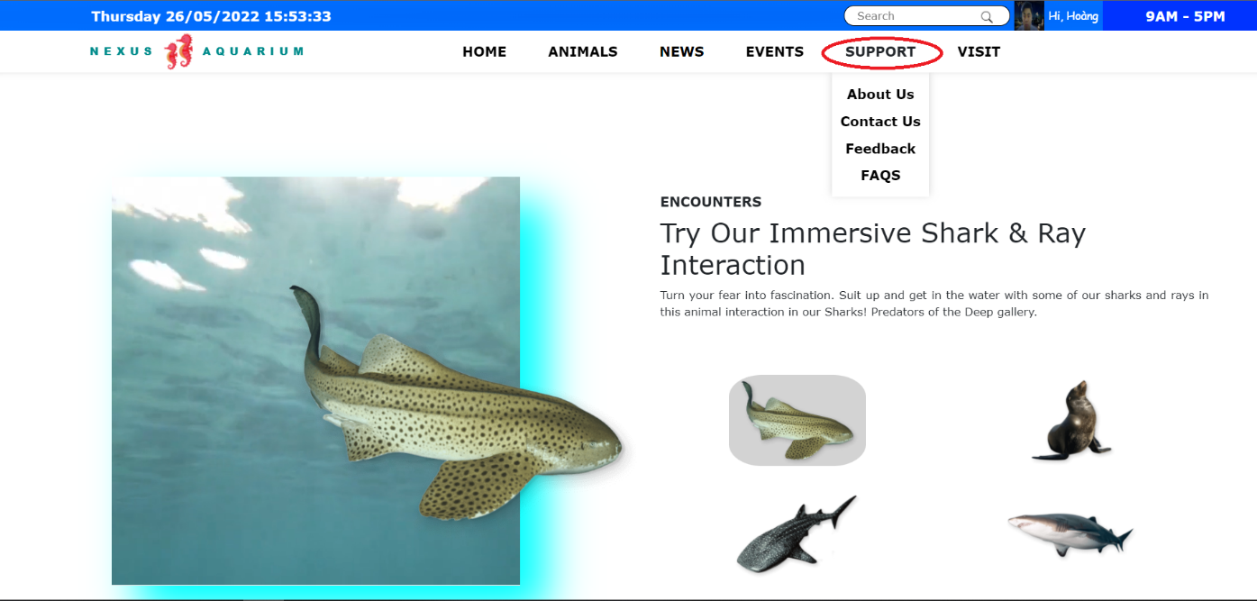

### 1.3.5.1 About us

### This function is used to introduce some information about Nexus Aquarium.

- Click to ‘About Us’ on the dropdown menu of ‘SUPPORT’

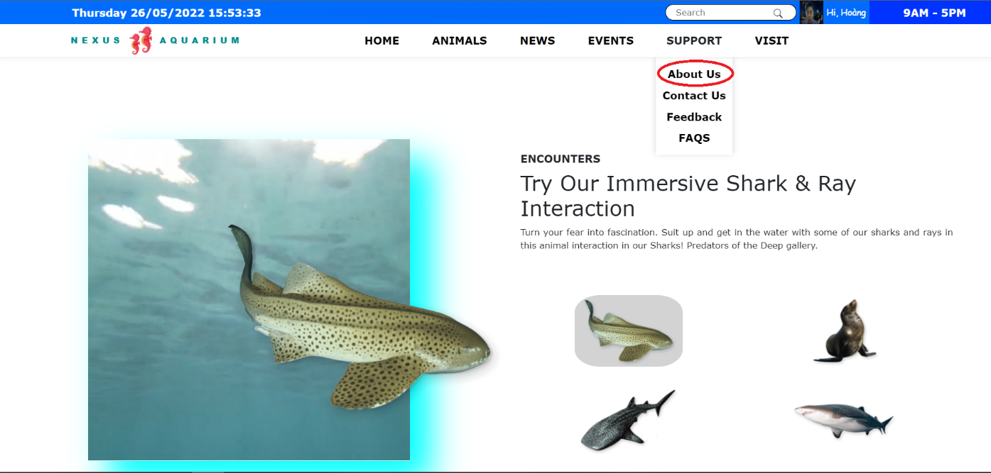

### 1.3.5.2 Contact Us

This function is used to show for users a few way to contact with Nexus Aquarium and the location of us.

- Click to ‘Contact Us’ on the dropdown menu of ‘SUPPORT’

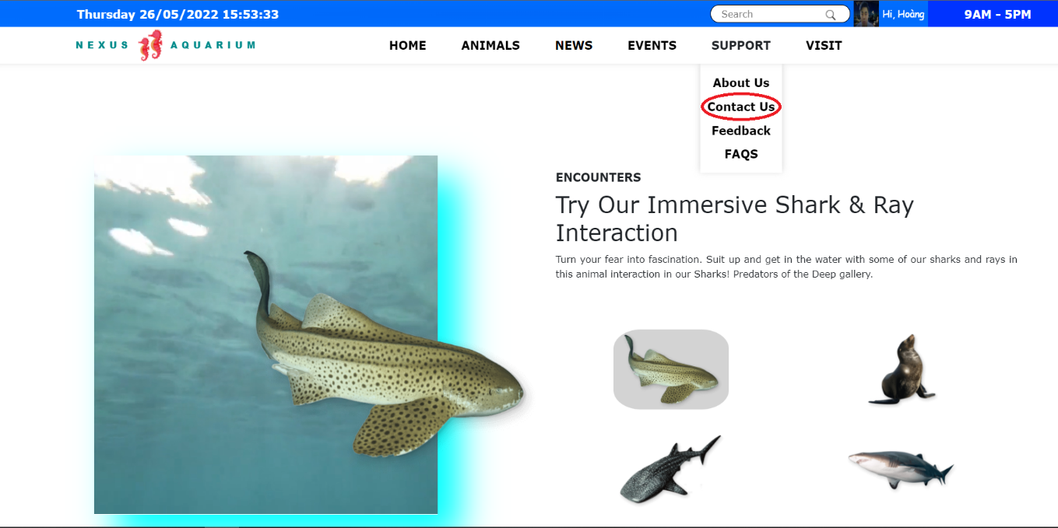

### 1.3.5.3 Feedback

This function allows you to send us your feedback (required to be logged in to the system).

* Step 1: Click to ‘Feedback’ on the dropdown menu of ‘SUPPORT’

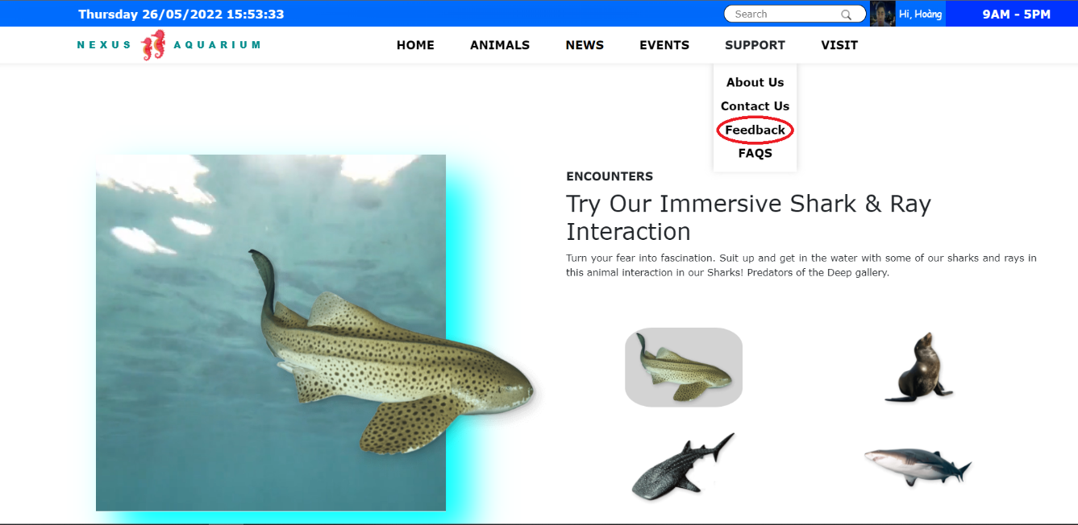

- Step 2: You can choose the field you want feedback



* Step 3: Write your feedback in the text box and press the ‘SUBMIT’ button to send us feedback.

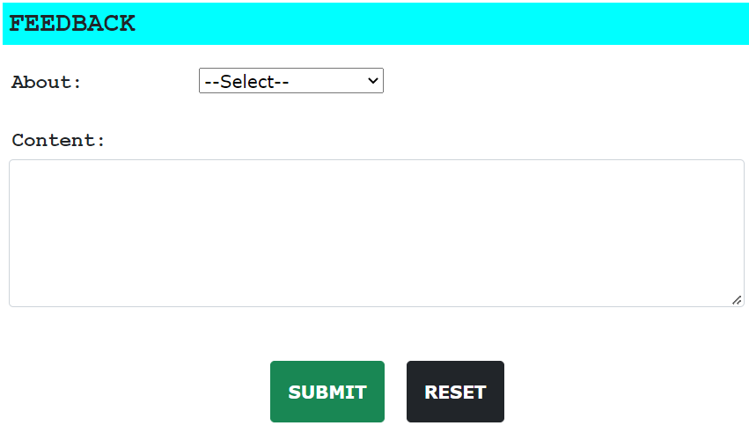

### 1.3.5.4 FAQS

### This function shows the user frequently asked questions and includes answers

* Step 1: Click to ‘FAQS’ on the dropdown menu of ‘SUPPORT’

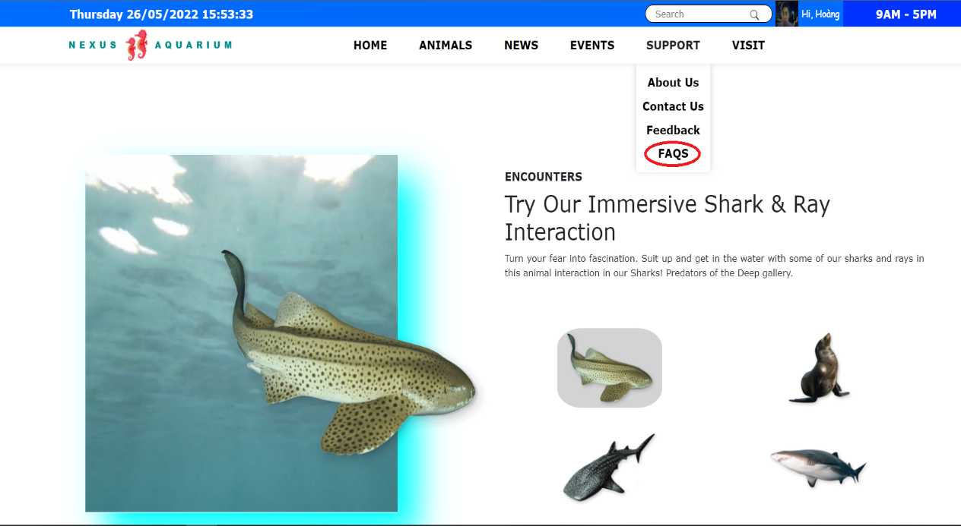

- Step 2: Click on the icon before each question to see the answer.

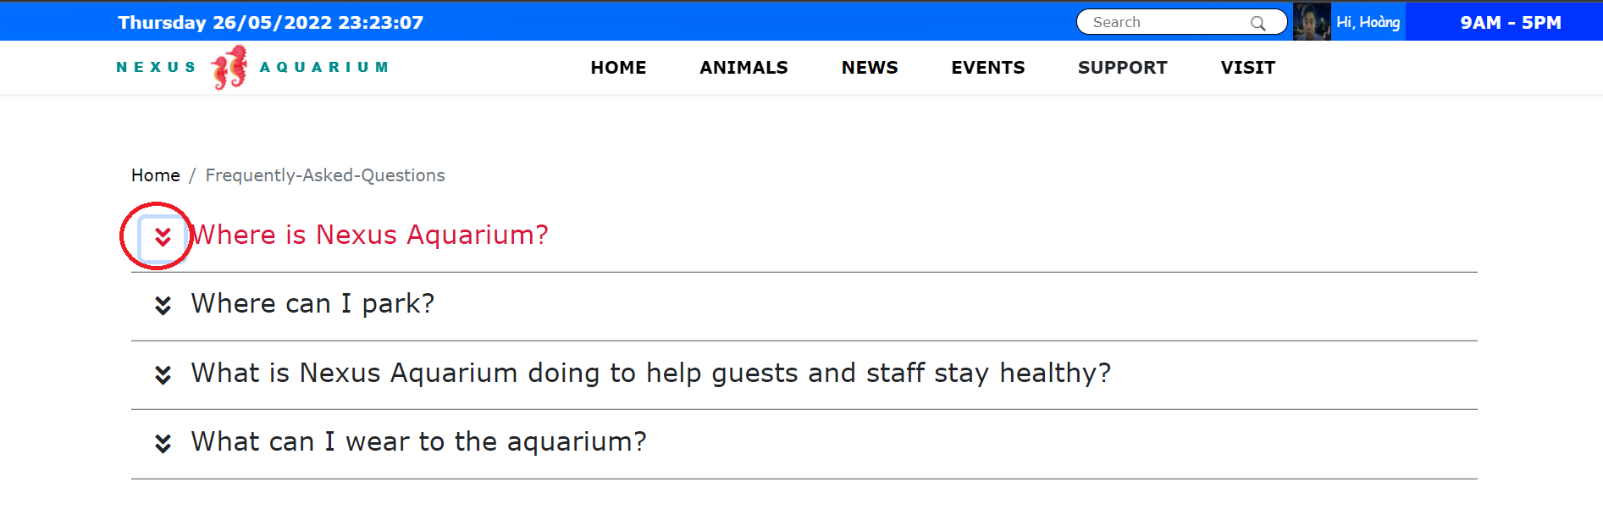

**2. WEBSITE ADMINISTRATION GUIDE**

## This section will instruct administrators on how to use the site in viewing, adding, editing and deleting objects of the site such as animals, news, events, … and so forth.

## 2.1 Login Admin Main Page

Subject: Web site Administrator

* Step 1: The administrator login the website the same way as users.
* Step 2: If the account (email and password) is verified and the role of the account is truly administrator, a button called **ADMIN** will appear in navbar at the top the Home page. This is the sign that this account is indeed the administrator.

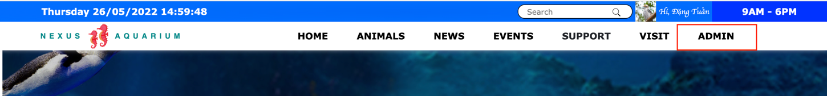

* Step 3: When the administrator clicks the button ADMIN, he/she will be redirected to the admin’s main page which contains a list of subjects that he/she can monitor such as bookings, events, animals, etc as described below

### 

- Step 4: From here the administrator can perform their work.

### Add New Admin:

Allow the administrator to create a new administrator:

- Step 1: In the admin’s main page, click the button 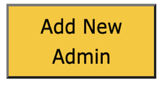 this screen will show up:

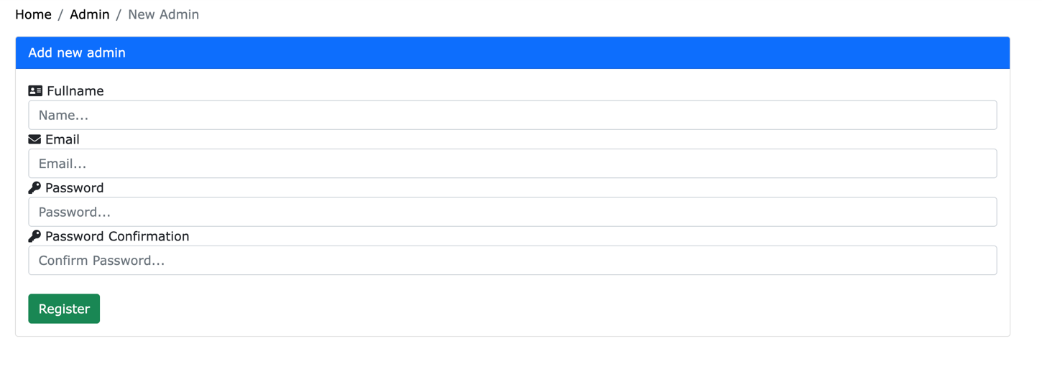

- Step 2: After the administrator has finished filling the new administrator’s information, click the button 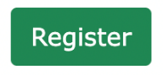 and voila, a new admin account has been created successfully.

## 2.3 User Accounts:

Subject: Web site administrator. Allow the administrator to register, edit and delete user accounts.

### 2.3.1 View the account list

Allow the administrator the see the list of user’s accounts (only those that are users)

* Step 1: Log in as administrator.
* Step 2: In the Admin’s main page, click the button 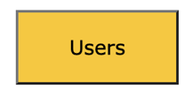and the list will be shown:

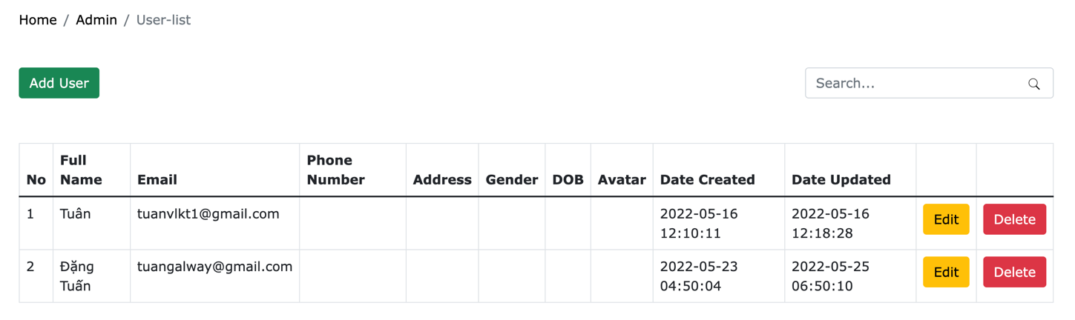

### 2.3.2 Add new accounts

This allows the administrator to create new user accounts. Normally when users create their own accounts, the system will send an email with a confirmation link so that users can verify that its them. But when the administrator uses this to create, the confirmation step is passed.

* Step 1: In the user account list page, click the button 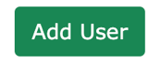and the following screen will be displayed:

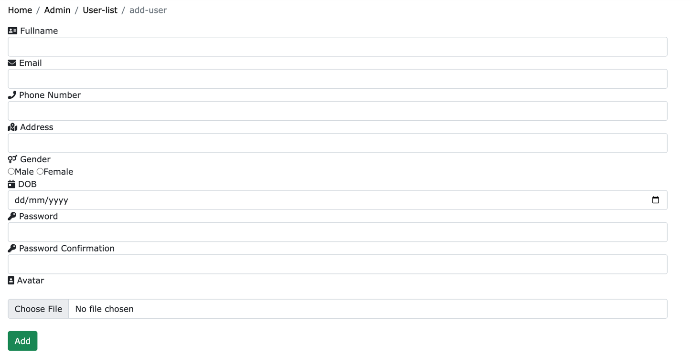

* Step 2: After filling in the user’s information, click the button 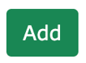 and the account is set without 2.1.2.3
  + 1. **Search Accounts:**

This allows the administrator the search users account by its username, email, etc.

* Step 1: In the User account list page, fill in the information of the account you want to search into the search bar and then click the icon  and the matched results will be displayed beneath.

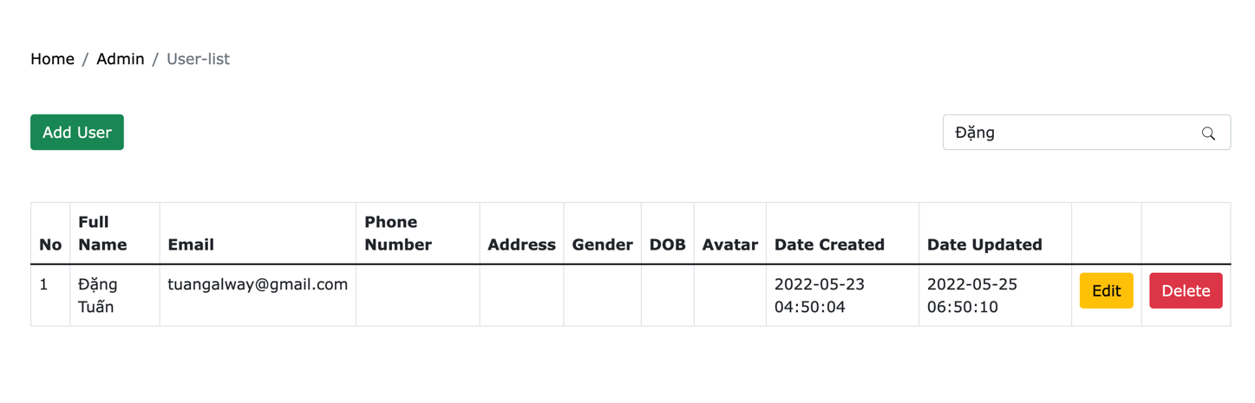

### Edit user accounts:

This allows the administrator to view and edit user account’s details.

* Step 1: In the user account’s list page, click the button on the right side of the account that you want to view/edit.
* Step 2: After editing the accounts details, click the button and your information will be updated onto the database

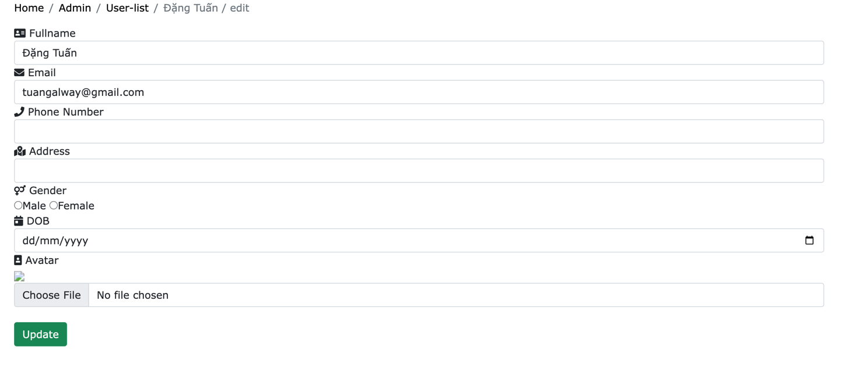

### Delete user accounts:

This allows the administrator the delete user’s accounts.

- Step 1: In the user account’s list page, click the button 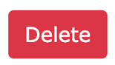on the right side of the account you want to delete

### - Step 2: Click the button OK to confirm your delete

### 

## 2.4 Animal Categories Management:

Subject: Website Administrator. This allows the administrator to add/edit/delete both animal categories

**2.4.1 list Animal Categories:**

- In the Admin’s Main Page, click on the button 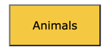 and the list of animal categories is shown:

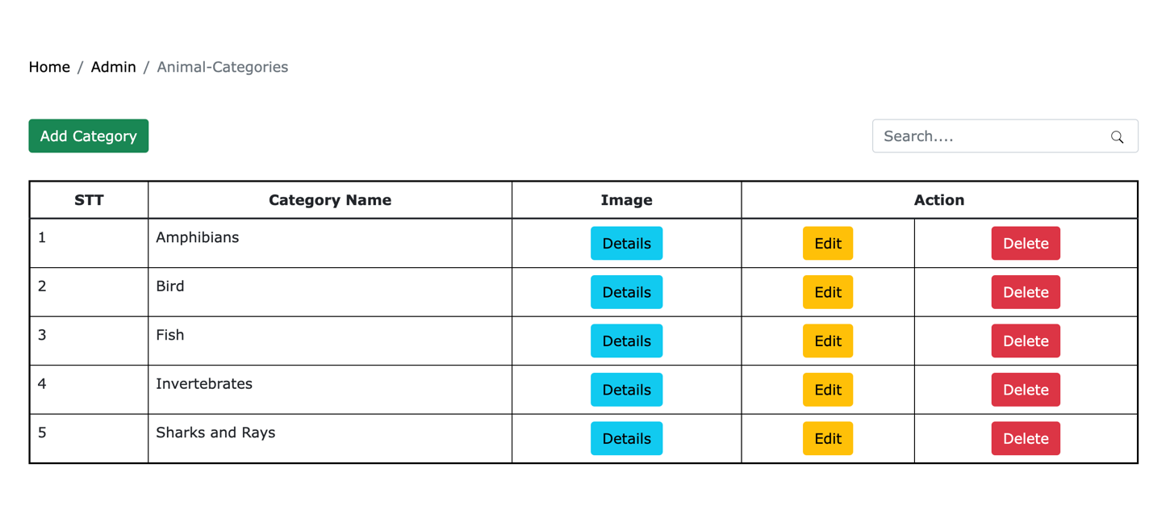

### 2.4.2 Add new Animal Categories:

### - Step 1: in the animal categories list page, click the button

### - Step 2: after filling in the animal categories details, click the button ADD

### 

### Edit Animal Categories

* Step 1: in the animal categories list page, click the button beside the row you want to edit.

- Step 2: After editing, click the button EDIT to confirm your action.

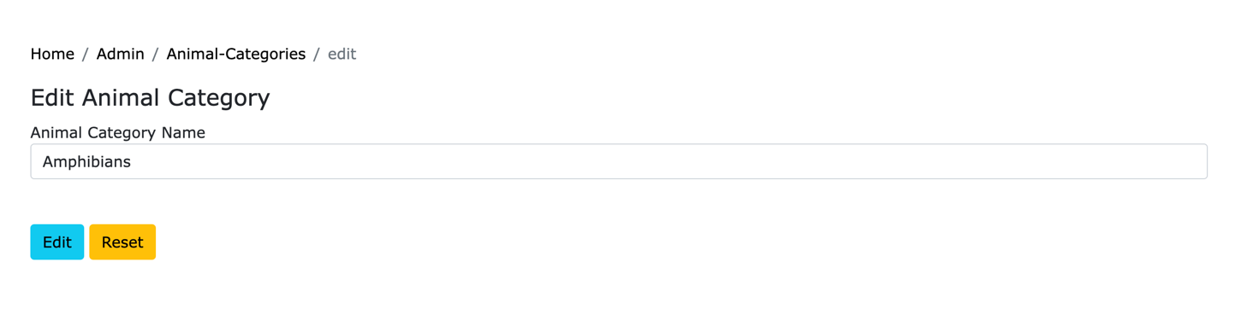

### 2.4.4 Delete Animal Categories

* Step 1: in the animal categories list page, click the button  beside the row you want to delete.

- Step 2: click the button  to confirm your action

*.* 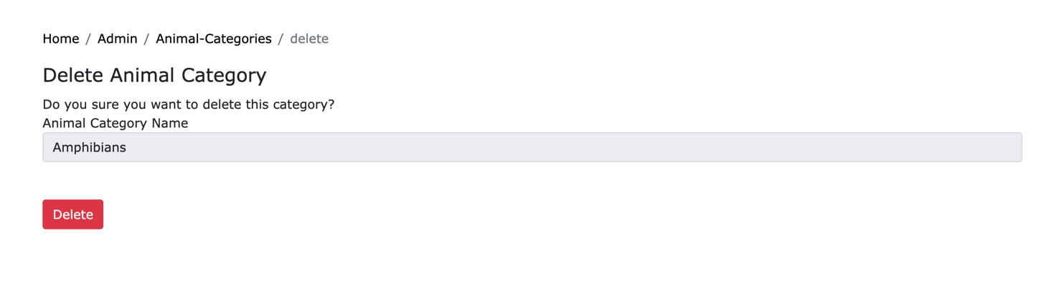

### 2.4.5 Search Animal Categories

* In the animal categories list page, fill in the information of the categories you are looking for, click the icon  and the matched categories will be displayed below.

## 

## 2.5 Animal Management

Subject: website Administrator

### 2.5.1 Search Animals

- Fill in the details of the animals you are looking for, click the icon and the matched animals will be displayed below

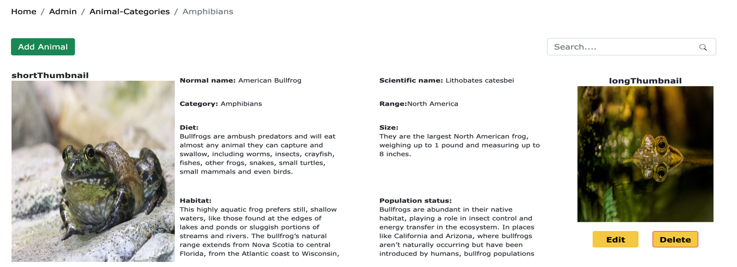

### List Animals:

Allows the administrator to see the list of animals of a specific category.

- In the animal categories page, click the button 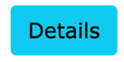 beside the category you want to see and the list of animals is shown.

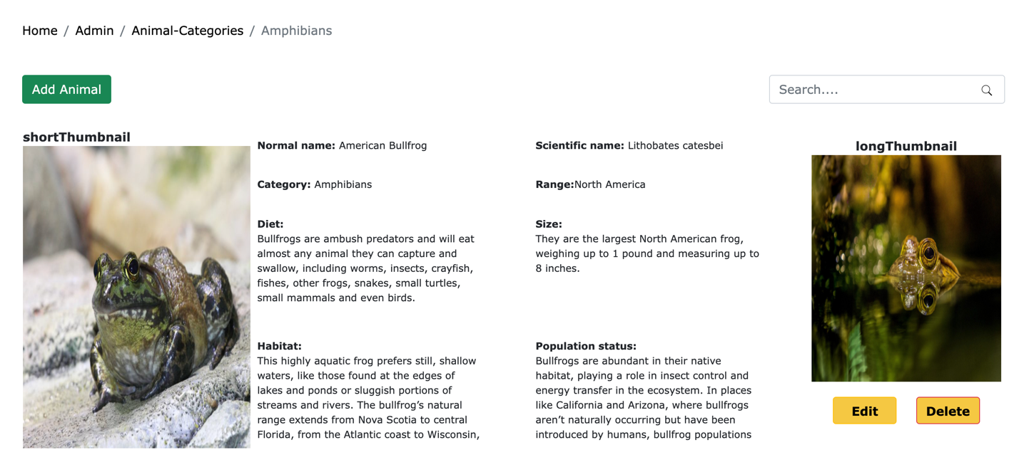

### 2.5.3 Add Animals:

Allows the administrator to add new animals of a specific category.

* Step 1: In the animal list page, click the button 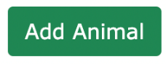.
* Step 2: After filling in the new animal’s details, click the button 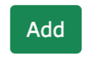 to confirm your action

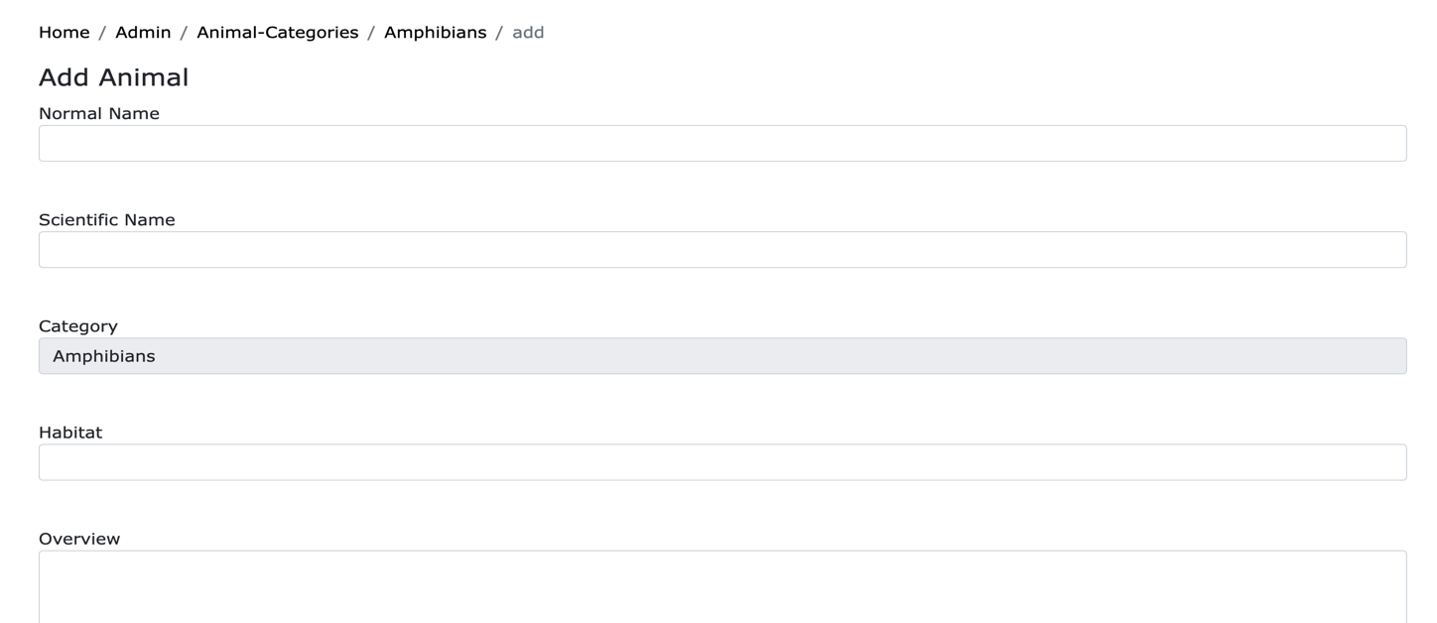

### 2.5.4 Delete Animals:

Allows the administrator to delete animals.

* Step 1: In the animal list page, click the button next to the animal you want to delete.
* Step 2: Click the button to confirm your action

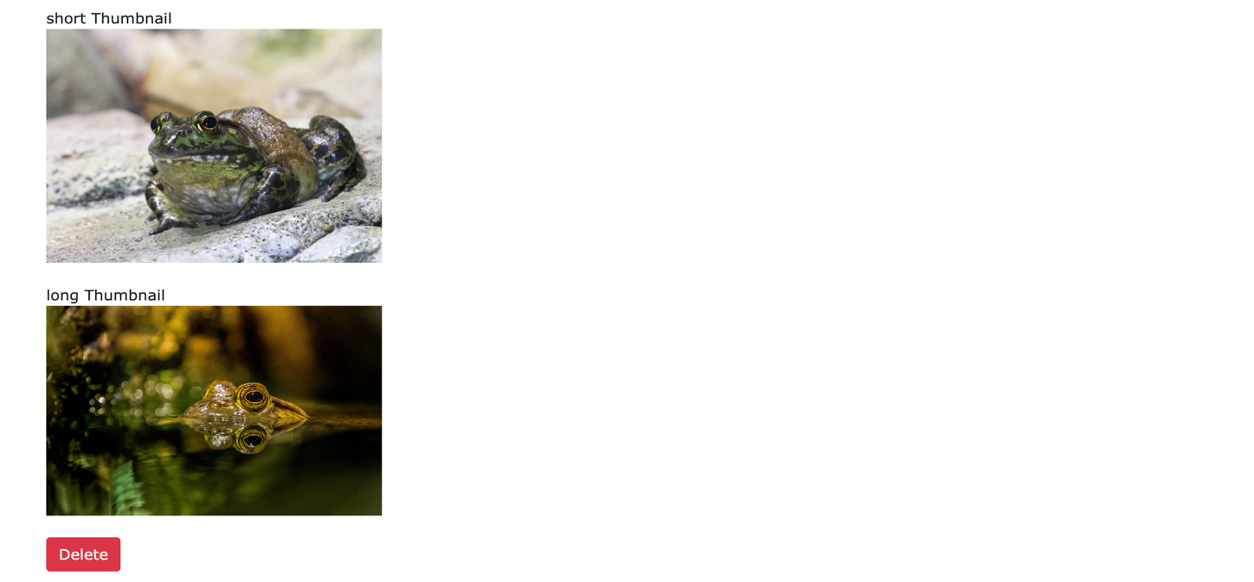

### 2.5.5 Edit Animals:

Allows the administrator to edit animals.

* Step 1: In the animal list page, click the button next to the animal you want to edit.
* Step 2: After editing the animal’s details, click the button to confirm your action

## 2.6 Post Categories Management

Subject: Website Administrator. This allows the administrator to add/edit/delete both post categories

**2.6.1 list Post Categories:**

- In the Admin’s Main Page, click on the button 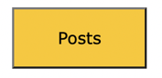 and the list of post categories is shown:

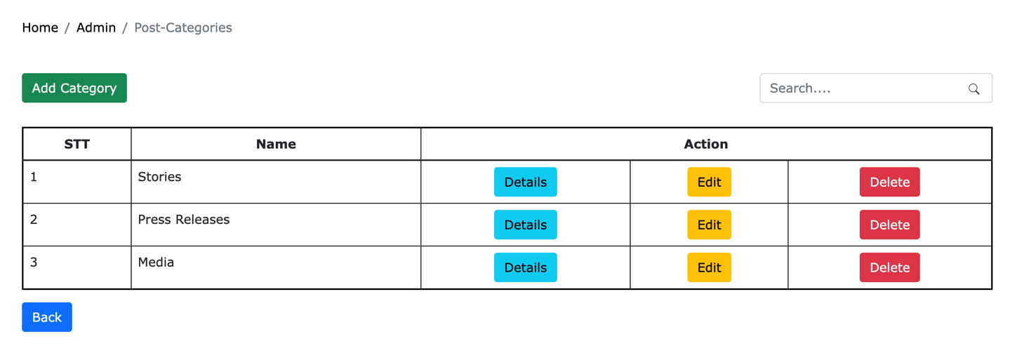

### 2.6.2 Add new Post Categories:

### - Step 1: in the post categories list page, click the button

### - Step 2: after filling in the post categories details, click the button ADD

### 

### Edit Post Categories

* Step 1: in the post categories list page, click the button beside the row you want to edit.

- Step 2: After editing, click the button EDIT to confirm your action.

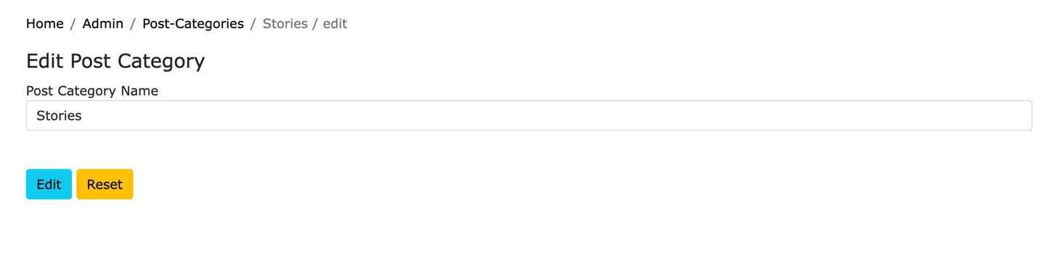

### 2.6.4 Delete Post Categories

* Step 1: in the post categories list page, click the button  beside the row you want to delete.

- Step 2: click the button  to confirm your action

*.* 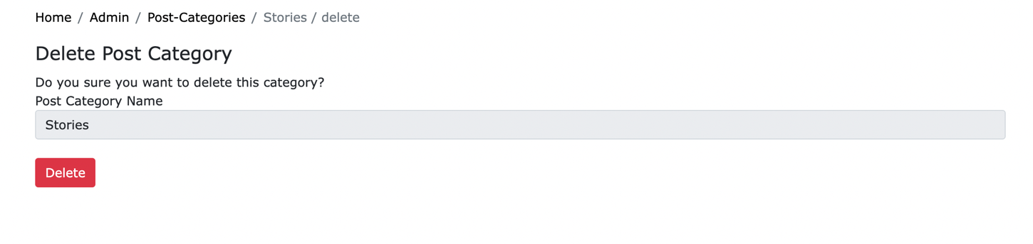

### 2.6.5 Search Post Categories

* In the post categories list page, fill in the information of the categories you are looking for, click the icon  and the matched categories will be displayed below.

## 2.7 Post Management

Subject: Website Administrator. This allows the administrator to add/edit/delete both posts

### List Post:

Allows the administrator to see the list of posts of a specific category.

- In the post categories page, click the button  beside the category you want to see and the list of posts is shown.

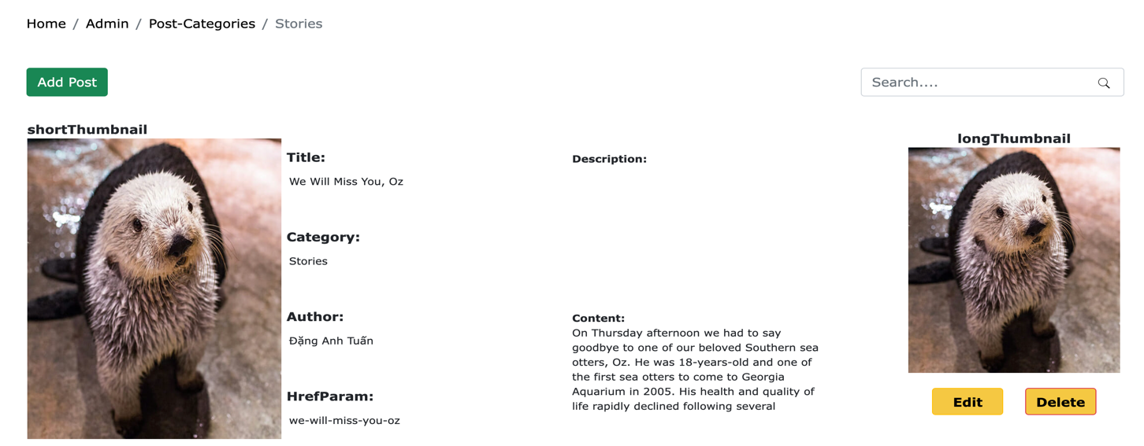

### 2.7.2 Add Posts:

Allows the administrator to add new posts of a specific category.

* Step 1: In the post list page, click the button 
* Step 2: After filling in the new post’s details, click the button  to confirm your action

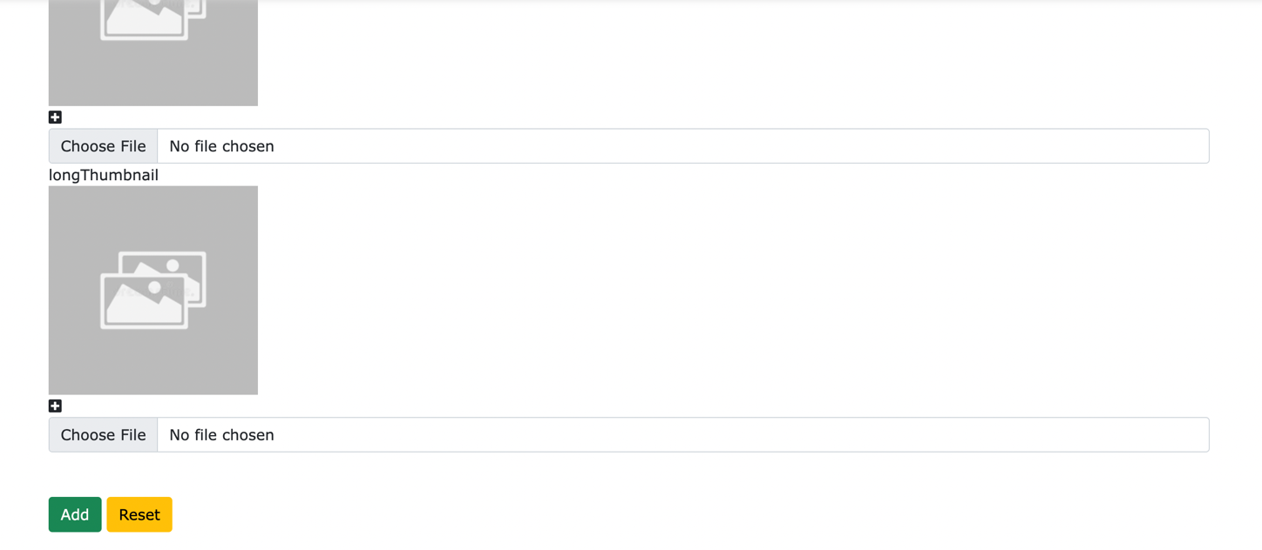

### 2.7.3 Delete Posts:

Allows the administrator to delete posts.

* Step 1: In the post list page, click the button next to the post you want to delete.
* Step 2: Click the button to confirm your action

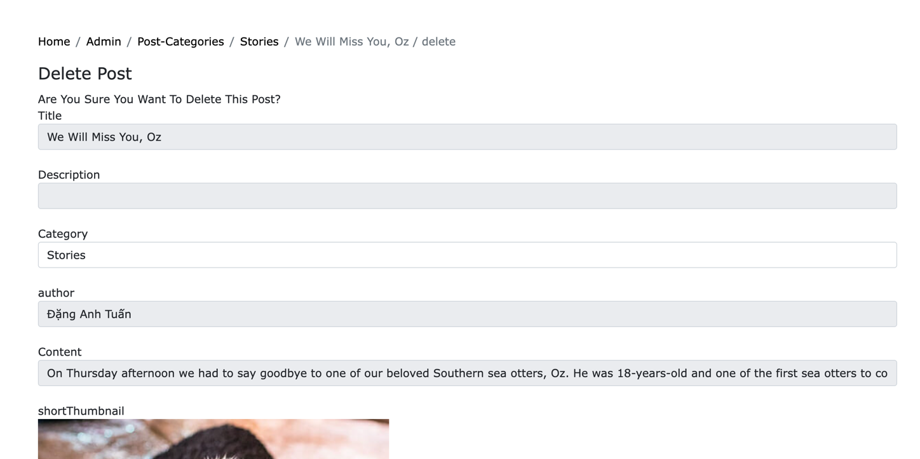

### 2.7.4 Edit Post:

Allows the administrator to edit posts.

* Step 1: In the post list page, click the button next to the post you want to edit.
* Step 2: After editing the post’s details, click the button to confirm your action

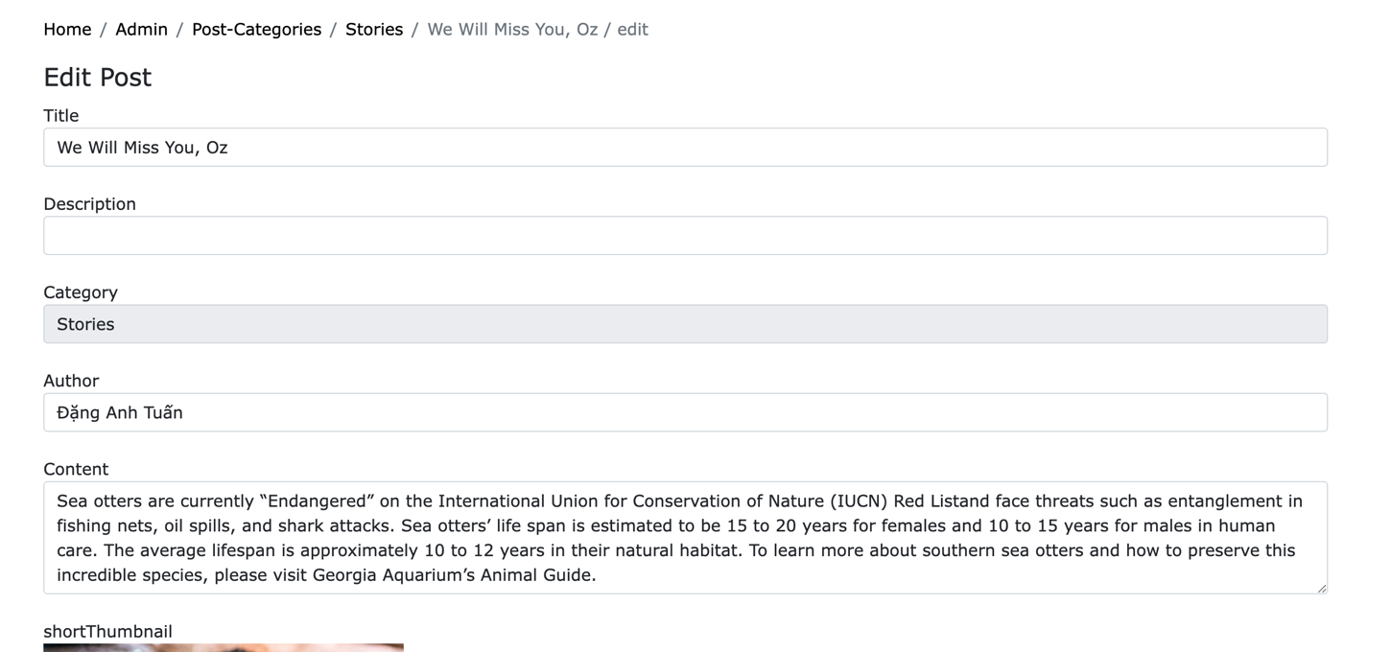

## 2.8 Ranges Management

Subject: Website Administrator. This allows the administrator to add/edit/delete animal’s ranges

### List Ranges:

Allows the administrator to see the list of ranges.

- In the admin’s main page, click the button 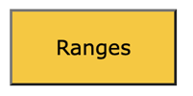and the range list will be presented

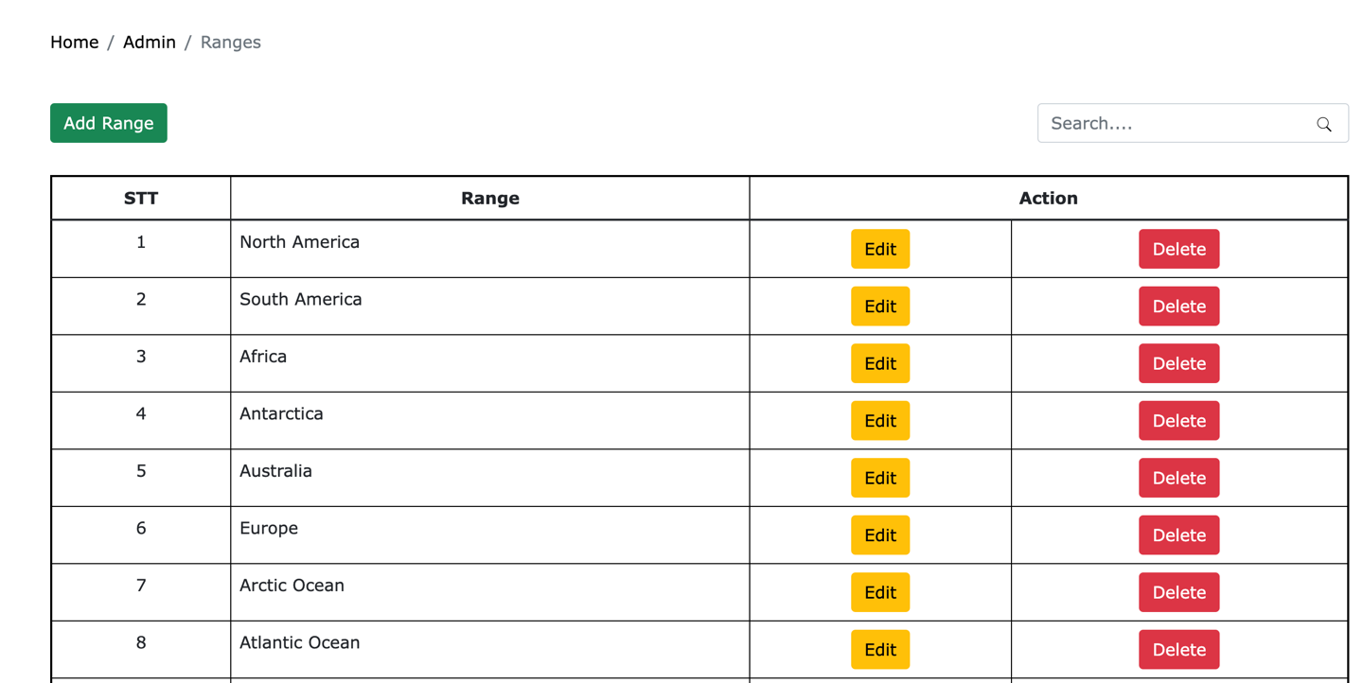

### 2.8.2 Add Ranges:

Allows the administrator to add new ranges.

* Step 1: In the range list page, click the button 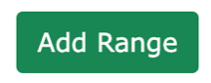
* Step 2: After filling in the new range’s details, click the button  to confirm your action

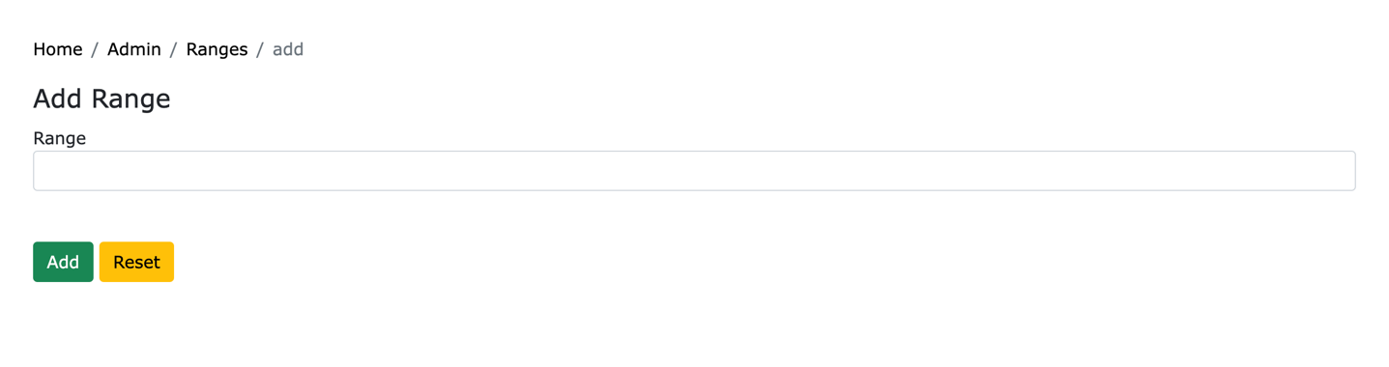

### 2.8.3 Delete Ranges:

Allows the administrator to delete ranges.

* Step 1: In the range list page, click the button next to the range you want to delete.
* Step 2: Click the button to confirm your action

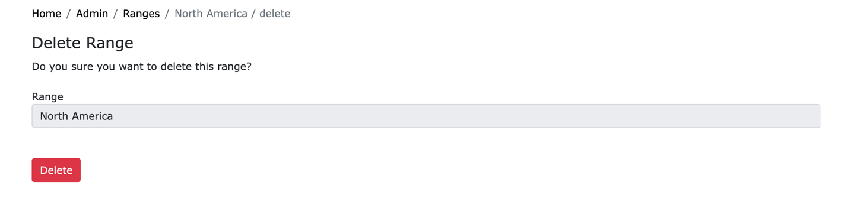

### 2.8.4 Edit Ranges:

Allows the administrator to edit ranges.

* Step 1: In the post list page, click the button next to the post you want to edit.
* Step 2: After editing the range’s details, click the button to confirm your action

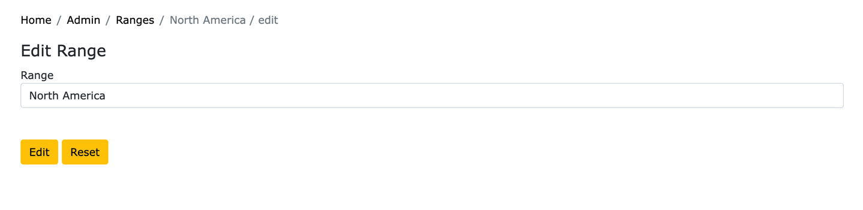

**2.8.5 Search Ranges:**

Allows the administrator to search for ranges by their name.

- In the range list page, fill in the search bar the name of the range you want, click the loop icon and matched results will be displayed below.

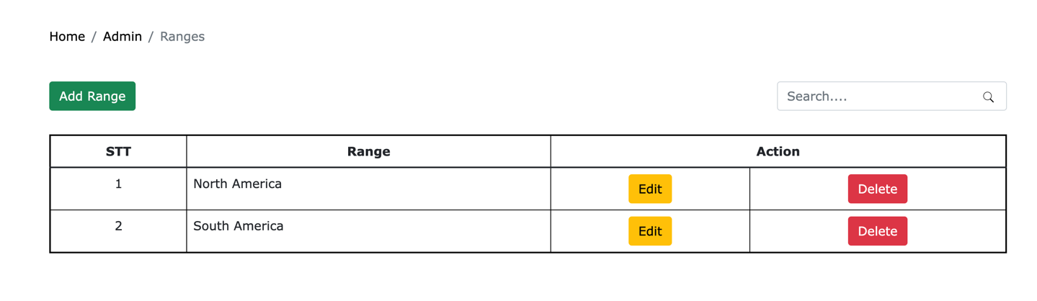

## 2.9 Random Background Management

Subject: Website Administrator. This allows the administrator to add/edit/delete random backgrounds

### List random Backgrounds:

Allows the administrator to see the list of random backgrounds.

- In the admin’s main page, click the button 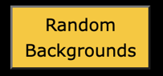and the random background list will be presented

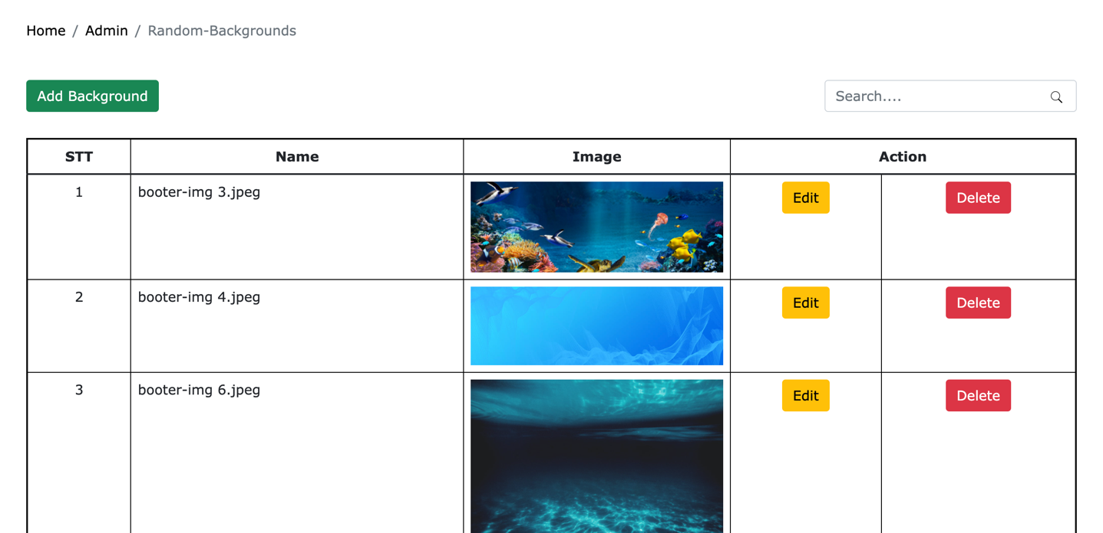

### 2.9.2 Add Random Backgrounds:

Allows the administrator to add new random backgrounds.

* Step 1: In the random background list page, click the button 
* Step 2: After filling in the new random background’s details, click the button  to confirm your action

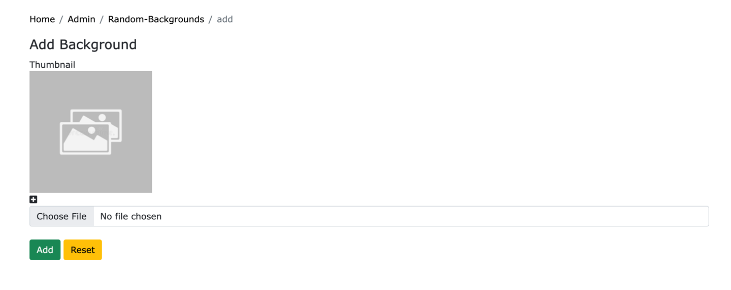

### 2.9.3 Delete Random Backgrounds:

Allows the administrator to delete random backgrounds.

* Step 1: In the random background list page, click the button next to the random background you want to delete.
* Step 2: Click the button to confirm your action

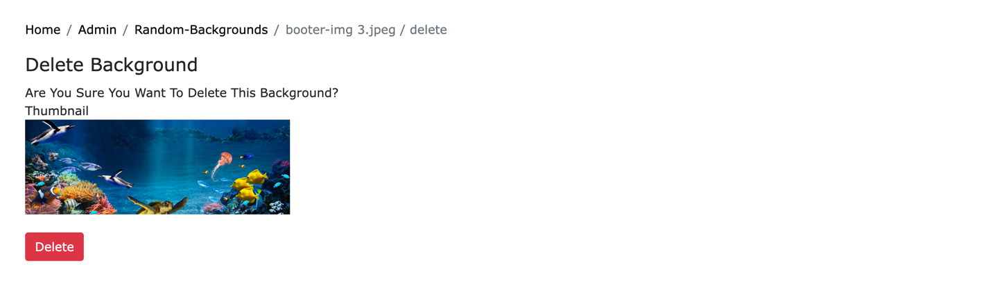

### 2.9.4 Edit Random Backgrounds:

Allows the administrator to edit random backgrounds.

- Step 1: In the random backgrounds list page, click the button next to the background you want to edit.

* Step 2: After editing the background’s details, click the button to confirm your action

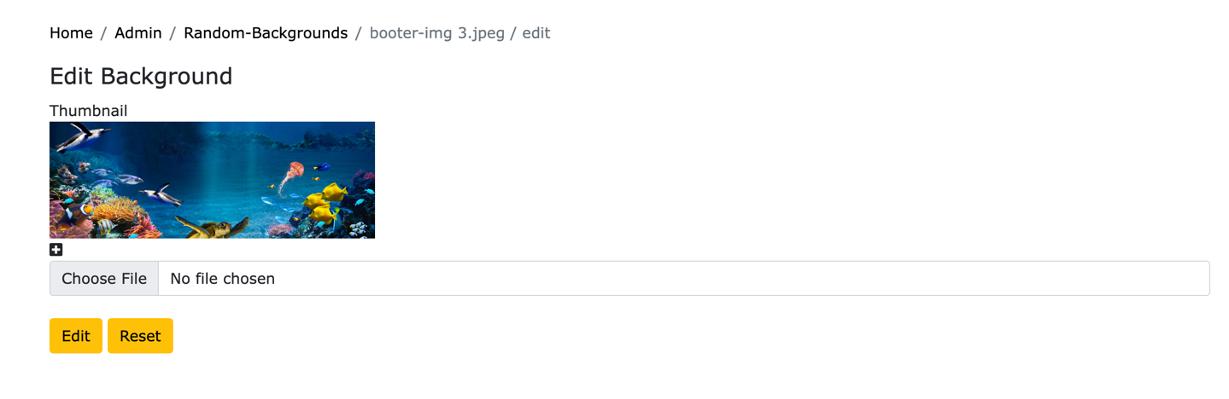

**2.9.5 Search Random Backgrounds:**

Allows the administrator to search for random backgrounds by their name.

- In the background list page, fill in the search bar the name of the background you want, click the icon  and matched results will be displayed below.

## 2.10 Author Management

Subject: Website Administrator. This allows the administrator to add/edit/delete Authors

### List Authors:

Allows the administrator to see the list of Authors.

- In the admin’s main page, click the button 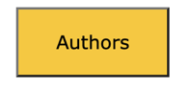and the author list will be presented

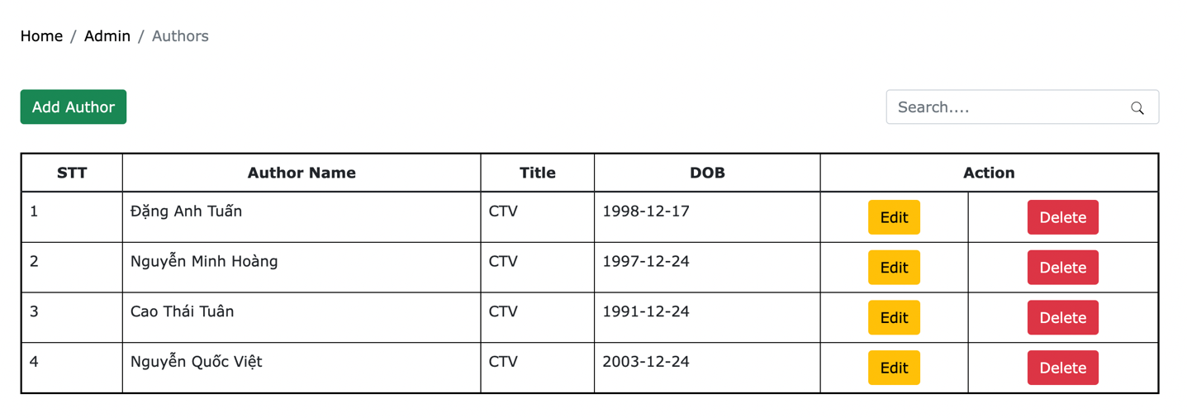

### 2.10.2 Add Authors:

Allows the administrator to add new Authors.

* Step 1: In the Authors list page, click the button 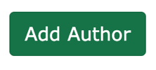
* Step 2: After filling in the new author’s details, click the button  to confirm your action

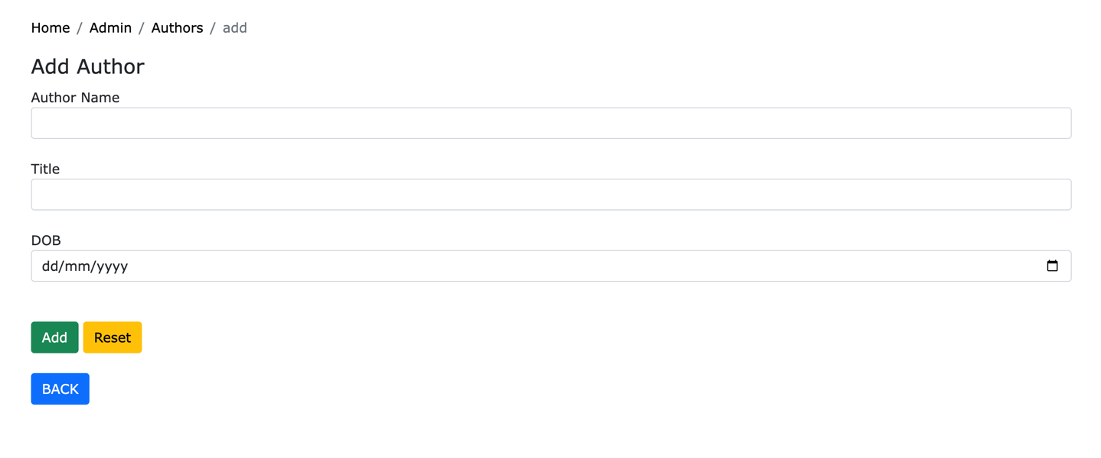

### 2.10.3 Delete Authors:

Allows the administrator to delete Authors.

* Step 1: In the Authors list page, click the button next to the Author you want to delete.
* Step 2: Click the button to confirm your action

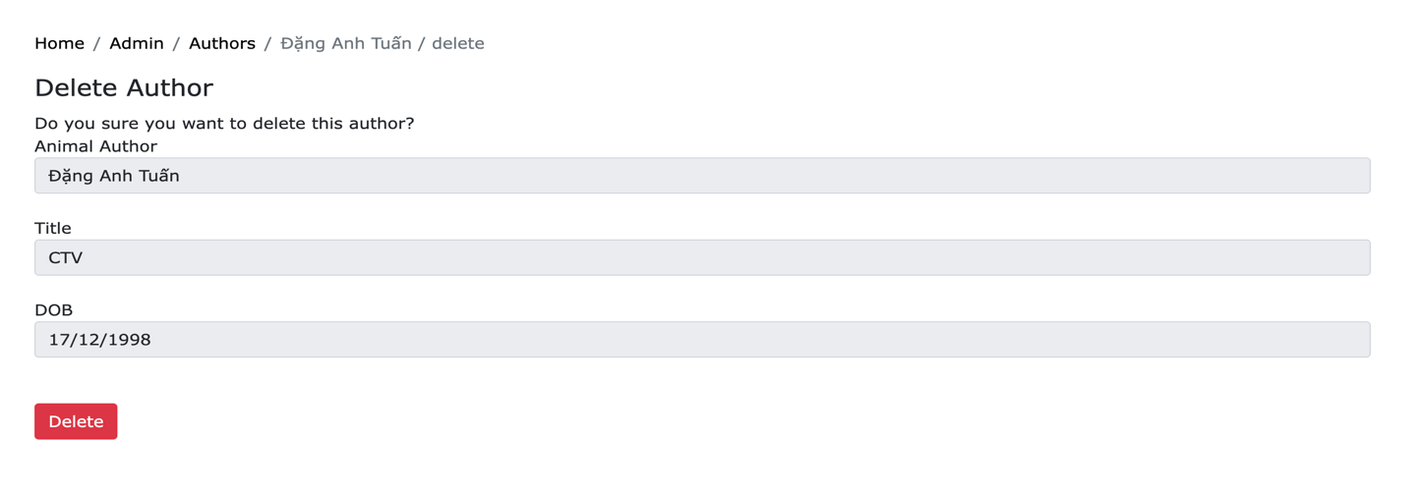

### 2.10.4 Edit Authors:

Allows the administrator to edit Authors.

- Step 1: In the Authors list page, click the button next to the Authors you want to edit.

* Step 2: After editing the Author’s details, click the button to confirm your action

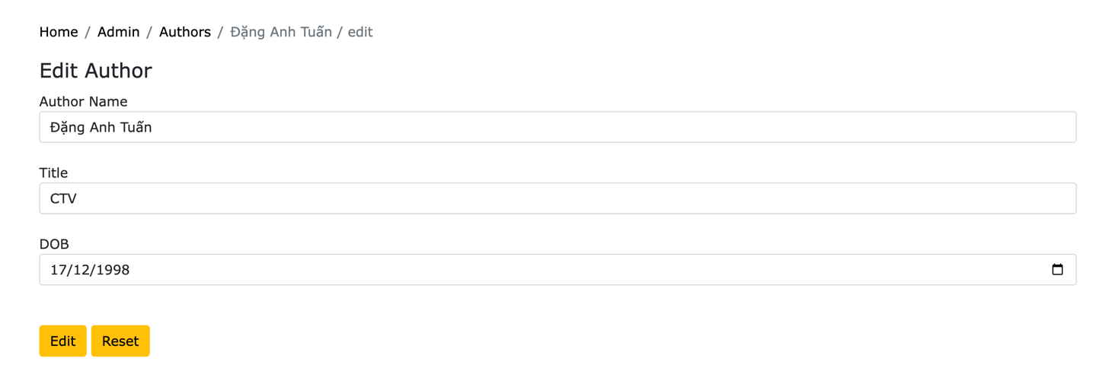

**2.10.5 Search Authors:**

Allows the administrator to search for authors by their name.

- In the authors list page, fill in the search bar the name of the authors you want, click the icon and matched results will be displayed below.

## 2.11 Event Categories Management

Subject: Website Administrator. This allows the administrator to add/edit/delete Event Categories

### List Event Categories:

Allows the administrator to see the list of Event Categories.

- In the admin’s main page, click the button 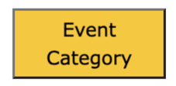and the Event Categories list will be presented

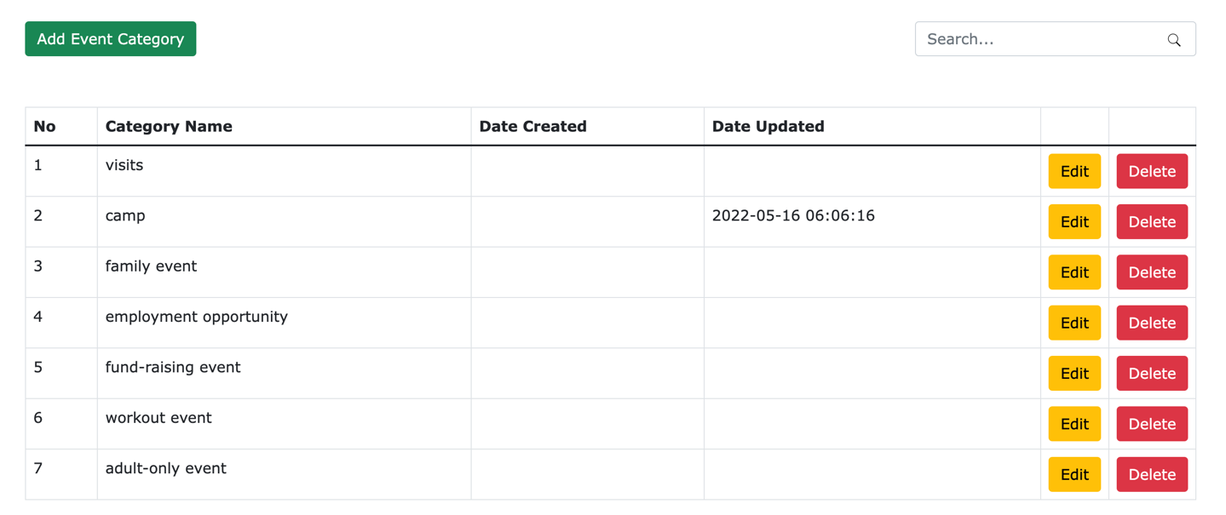

### 2.11.2 Add Event Categories:

Allows the administrator to add new Event Categories.

* Step 1: In the Event Categories list page, click the button 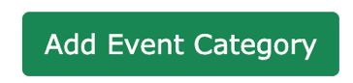
* Step 2: After filling in the new category’s details, click the button  to confirm your action

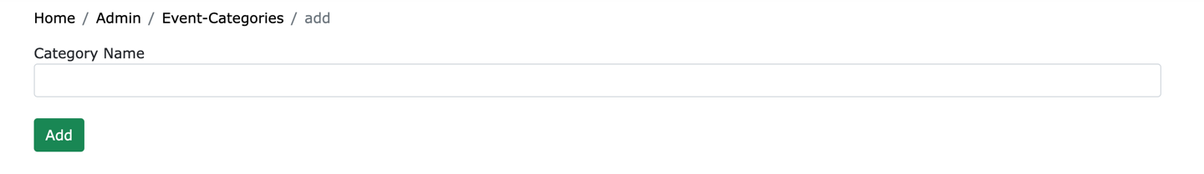

### 2.11.3 Delete Event Categories:

Allows the administrator to delete Event Categories.

* Step 1: In the Event Categories list page, click the button next to the Event Category you want to delete.
* Step 2: Click the button to confirm your action

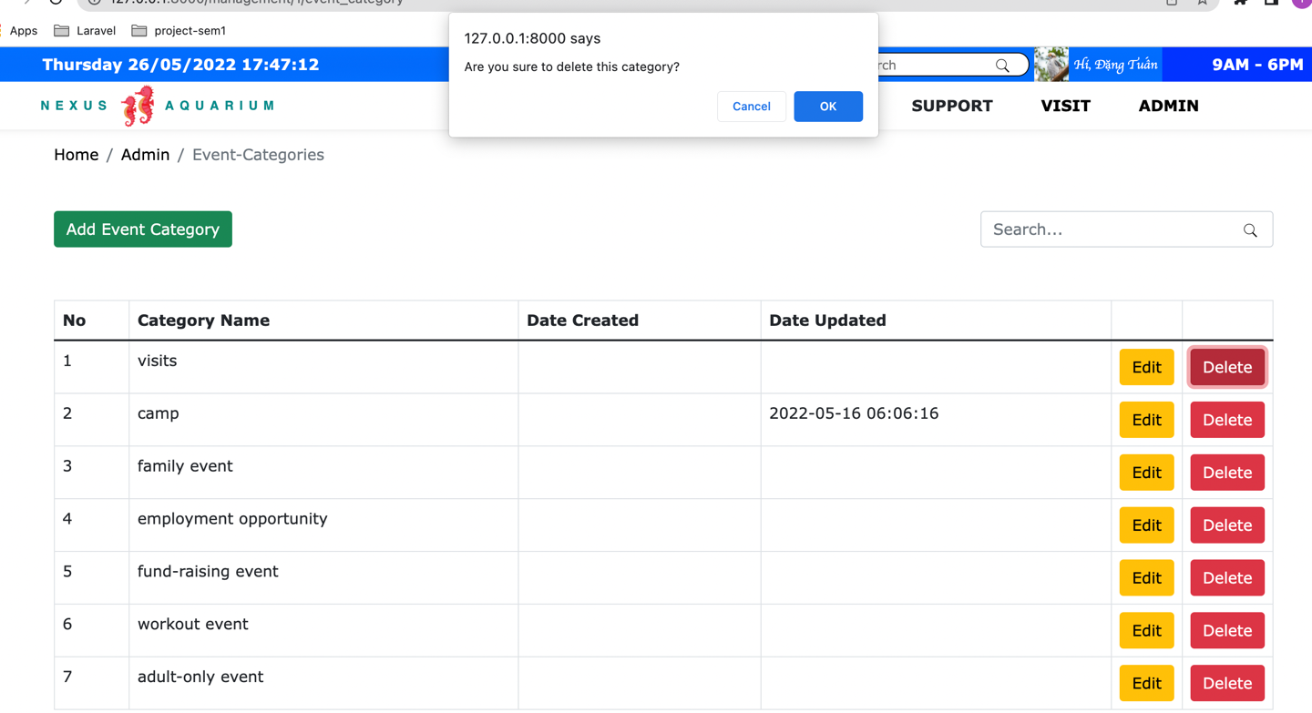

### 2.11.4 Edit Event Categories:

Allows the administrator to edit Event Categories.

- Step 1: In the Event Categories list page, click the button next to the Event Category you want to edit.

* Step 2: After editing the category’s details, click the button to confirm your action

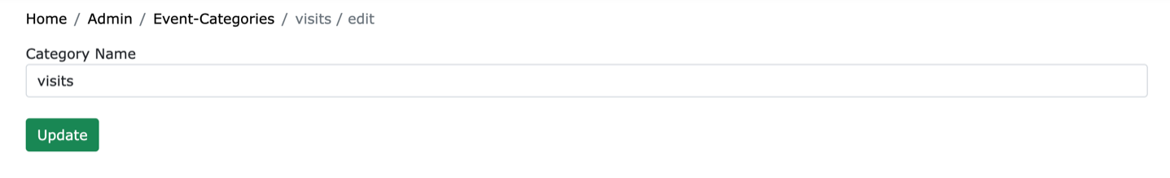

**2.11.5 Search Event Categories:**

Allows the administrator to search for Event Categories by their name.

- In the Event Categories list page, fill in the search bar the name of the Event Categories you want, click the icon  and matched results will be displayed below.

## 2.12 Events Management

Subject: Website Administrator. This allows the administrator to add/edit/delete Events

### List Events:

Allows the administrator to see the list of Evens.

- In the admin’s main page, click the button 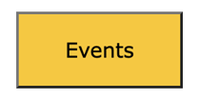and the Events list will be presented

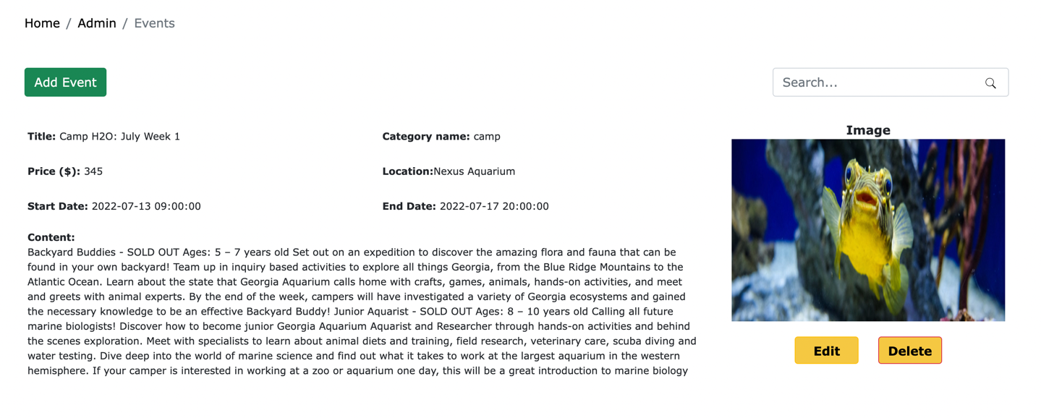

### 2.12.2 Add Events:

Allows the administrator to add new Evens.

* Step 1: In the Events list page, click the button 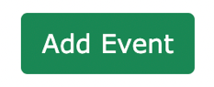
* Step 2: After filling in the new event’s details, click the button  to confirm your action

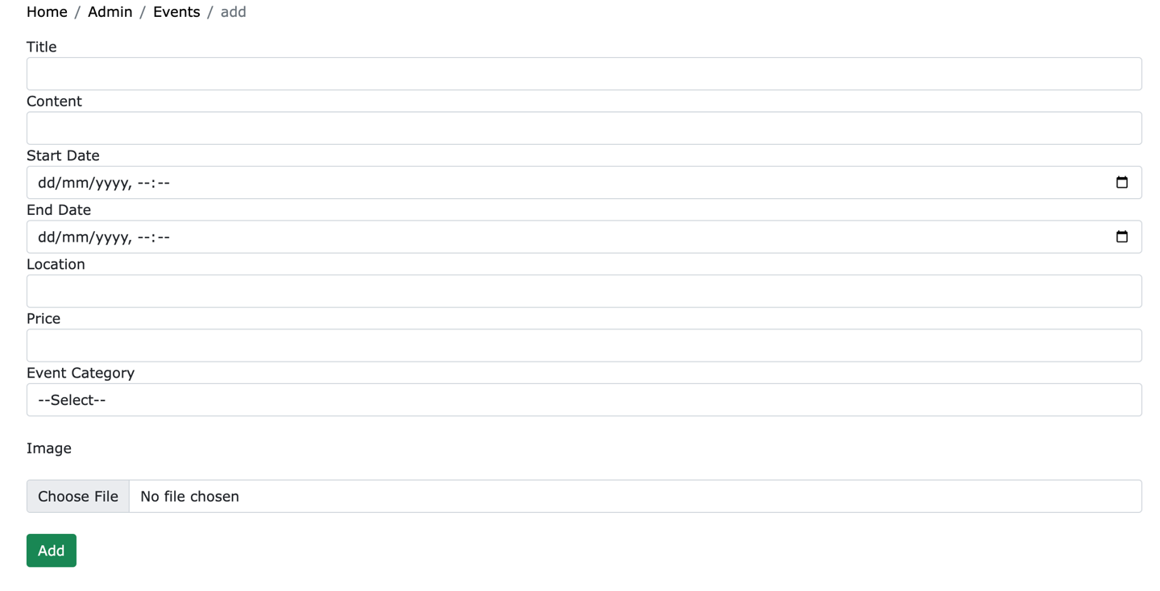

### 2.12.3 Delete Events:

Allows the administrator to delete Events.

* Step 1: In the Events list page, click the button next to the Event you want to delete.
* Step 2: Click the button to confirm your action

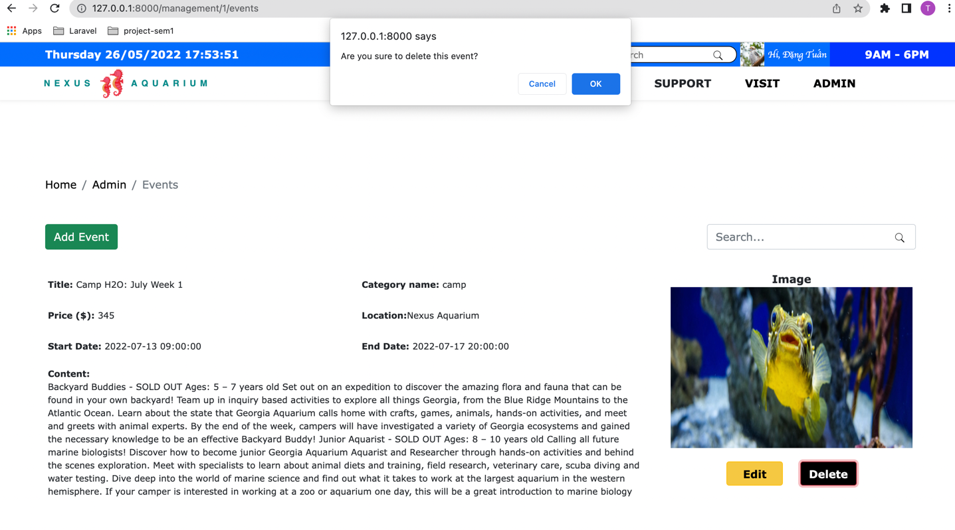

### 2.12.4 Edit Events:

Allows the administrator to edit Events.

- Step 1: In the Events list page, click the button next to the Event you want to edit.

* Step 2: After editing the event’s details, click the button to confirm your action

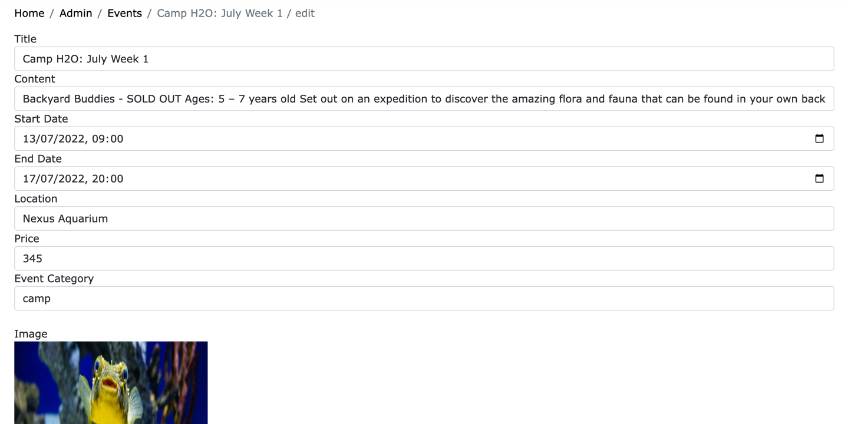

**2.12.5 Search Events:**

Allows the administrator to search for Events by their name.

- In the Events list page, fill in the search bar the name of the Events you want, click the icon  and matched results will be displayed below.

## 2.13 Feedback Categories Management

Subject: Website Administrator. This allows the administrator to add/edit/delete Feedback Categories

### List Feedback Categories:

Allows the administrator to see the list of Feedback Categories.

- In the admin’s main page, click the button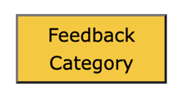 and the Feedback Categories list will be presented

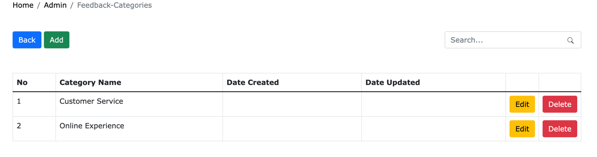

### 2.13.2 Add Feedback Categories:

Allows the administrator to add new Feedback Categories.

* Step 1: In the Feedback Categories list page, click the button 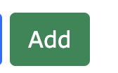
* Step 2: After filling in the new category’s details, click the button  to confirm your action

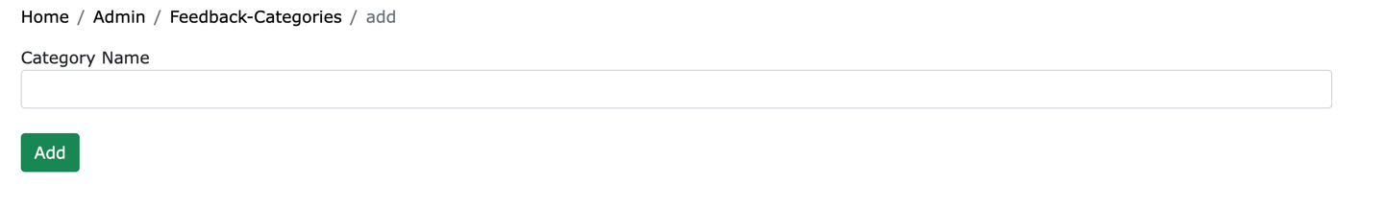

### 2.13.3 Delete Feedback Categories:

Allows the administrator to delete Feedback Categories.

* Step 1: In the Feedback Categories list page, click the button next to the Feedback Category you want to delete.
* Step 2: Click the button to confirm your action

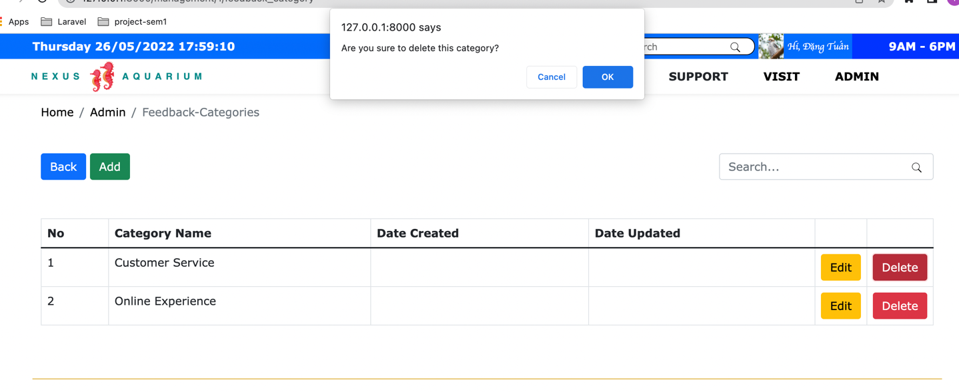

### 2.13.4 Edit Feedback Categories:

Allows the administrator to edit Feedback Categories.

- Step 1: In the Feedback Categories list page, click the button next to the Feedback Category you want to edit.

* Step 2: After editing the category’s details, click the button to confirm your action

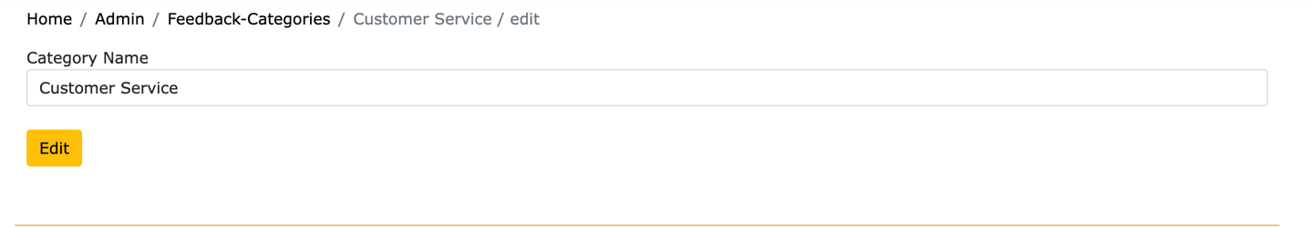

**2.13.5 Search Feedback Categories:**

Allows the administrator to search for Feedback Categories by their name.

- In the Feedback Categories list page, fill in the search bar the name of the Feedback Categories you want, click the icon  and matched results will be displayed below.

## 2.14 Feedbacks Management

Subject: Website Administrator. This allows the administrator to edit/delete Feedbacks

### List Feedbacks:

Allows the administrator to see the list of Feedbacks.

- In the admin’s main page, click the button 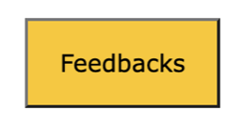 and the Feedbacks list will be presented

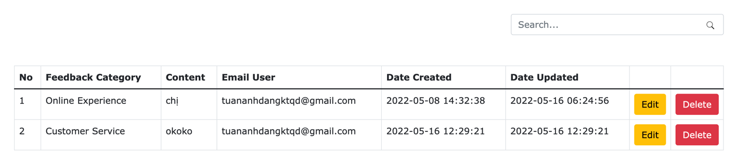



### 2.14.2 Delete Feedbacks:

Allows the administrator to delete Feedbacks.

* Step 1: In the Feedbacks list page, click the button next to the Feedback you want to delete.
* Step 2: Click the button to confirm your action

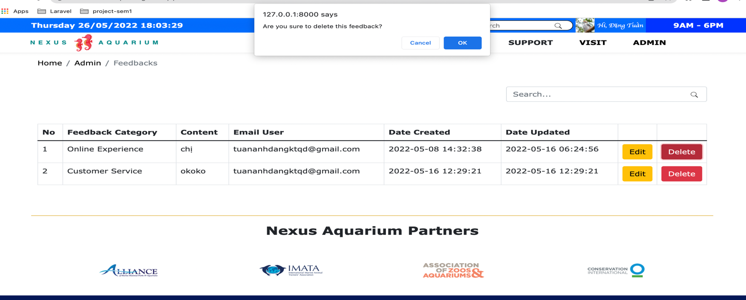

### 2.14.3 Edit Feedbacks:

Allows the administrator to edit Feedbacks.

- Step 1: In the Feedbacks list page, click the button next to the Feedback you want to edit.

* Step 2: After editing the feedback’s details, click the button to confirm your action

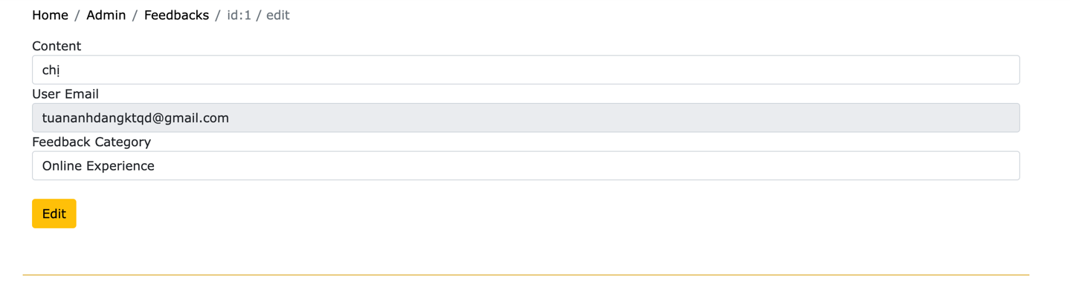

**2.14.4 Search Feedbacks:**

Allows the administrator to search for Feedbacks by their name.

- In the Feedback list page, fill in the search bar the name of the Feedback you want, click the icon  and matched results will be displayed below.

## 2.15 Bookings Management

Subject: Website Administrator. This allows the administrator to edit/delete Bookings

### List Bookings:

Allows the administrator to see the list of Bookings.

- In the admin’s main page, click the button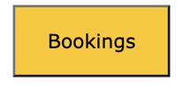 and the Bookings list will be presented

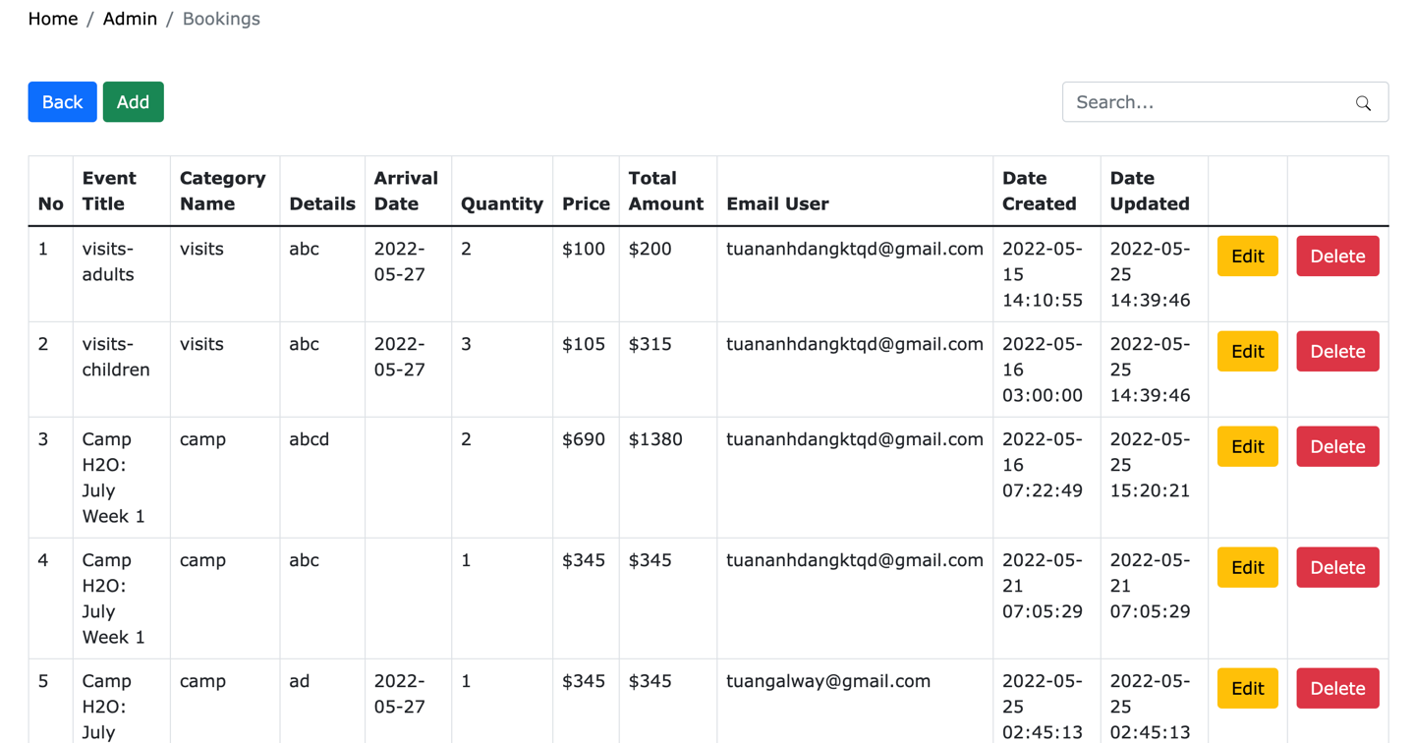

### 2.15.2 Add Bookings:

Allows the administrator to add Bookings.

- Step 1: In the Bookings list page, click the button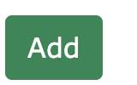

- Step 2: select the event of the booking and click the button 

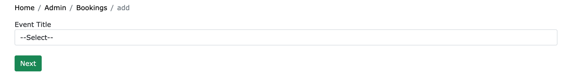

- Step 3: select the quantity/details and user email of the booking and click the button 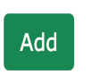 to confirm your action

### 

### 2.15.3 Delete Bookings:

Allows the administrator to delete Bookings.

* Step 1: In the Bookings list page, click the button next to the Booking you want to delete.
* Step 2: Click the button to confirm your action

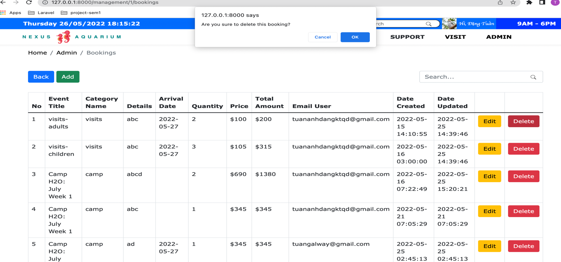

### 2.15.4 Edit Bookings:

Allows the administrator to edit Bookings.

- Step 1: In the Bookings list page, click the button next to the Booking you want to edit.

- Step 2: select the new event of the booking (the default value is the old event) and click the button 

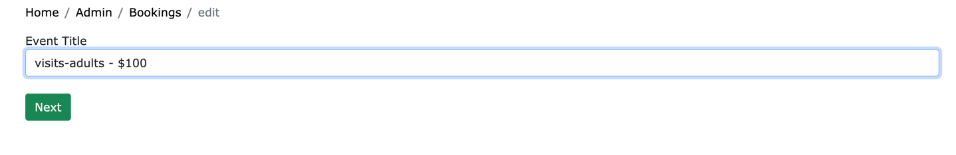

* Step 3: select the new quantity/details and user email of the booking (the default values are from the old booking) and click the button  to confirm your action

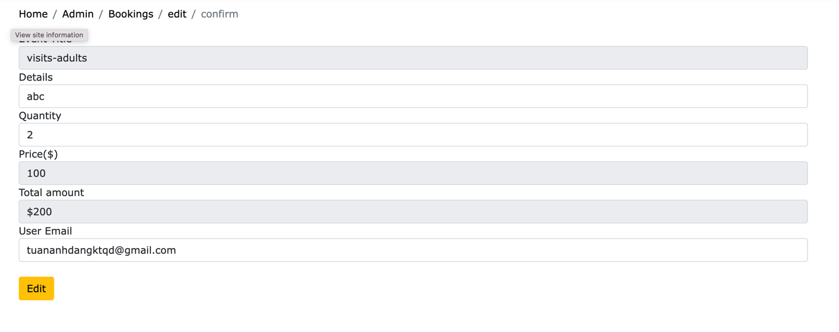

**2.15.5 Search Bookings:**

Allows the administrator to search for Bookings by their name.

- In the Bookings list page, fill in the search bar the name of the Bookings you want, click the icon  and matched results will be displayed below.